**Build a Network Monitoring Solution Using AWS VPC Flow Logs and CloudWatch**

Created by[Stephane Maarek | AWS Certified Cloud Practitioner,Solutions Architect,Developer](https://deloittedevelopment.udemy.com/user/stephane-maarek/)

**AWS Workspace**

**90-120 minutes**

In this lab, you will experience what its like to be a SysOps Administrator building a network monitoring solution for a company. Recently, the company has detected malicious activities that threaten the network infrastructure at the company. Now, the company wants to build a network monitoring solution to meet compliance requirements, monitor key metrics and set up automated notifications. You have been tasked with designing and implementing a network monitoring system that meets these requirements.

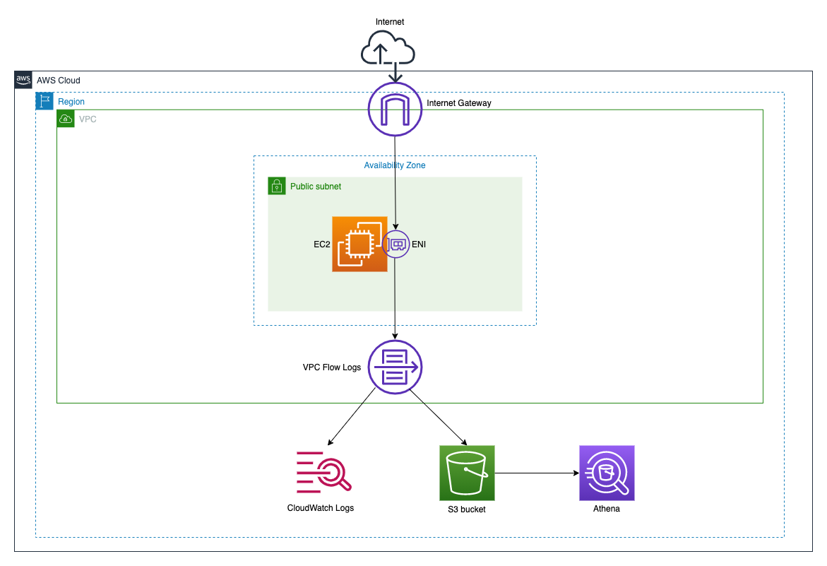

Our SysOps Administration team has been tasked to design and implement a network monitoring solution for our company. In the past, the company has detected malicious activities aimed at disrupting the network infrastructure at the company. We need you to devise a network monitoring solution that helps the company to meet compliance requirements, monitor key metrics and configure automated notifications in case of any suspected security event. On the network monitoring side, we want you to implement AWS VPC Flow Logs for your VPCs network interfaces.

To build a logging and notifications layer for the entire end-to-end solution, you will leverage CloudWatch filters and CloudWatch alarms to monitor AWS VPC Flow Logs that are ingested into CloudWatch Logs. We want you to report any security events via SNS notifications as soon as these are detected. You will need to build the analytics layer using Amazon Athena that analyzes the access trends for the VPC Flow Logs stored in S3.

**How you'll work**

Your project has been broken into a set of tasks. To complete these tasks, use the provided workspace. You can launch your workspace by clicking below or using the button in the top right of the screen.

Tasks

1-Create VPC and its sub-resources to facilitate VPC Flow Logs

2-Create VPC Flow Logs with destination as Cloudwatch Logs and S3

3-Provision an EC2 to capture traffic logs into the VPC flow logs

4-Configure CloudWatch metric-filter and cloudwatch alarm to monitor traffic

5-Use Athena to analyze the access trend for the VPC Flow Logs stored in S3

6-Clean Up

Create VPC and its sub-resources to facilitate VPC Flow Logs

To implement this step, you need to set up a new VPC and then create a public subnet in this VPC. You will provision an Internet Gateway and make route entries for the Internet Gateway in the main Route Table for the given VPC.

1. Make sure that you are in the N.Virginia AWS Region on the AWS Management Console. Enter **VPC** in the search bar and select **VPC**service.

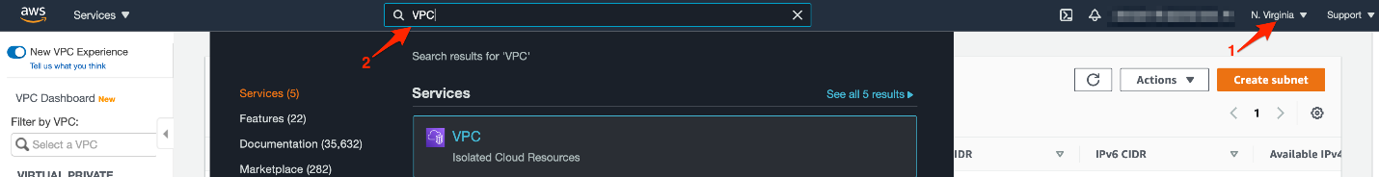

1. Lets create a new VPC that will be used to create the VPC Flow Log in a subsequent task.
   1. Click on the **Your VPCs** link in the left sidebar and then click **Create VPC** button

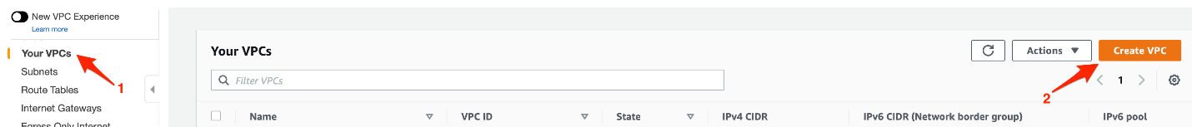

* 1. Enter the following values to create the VPC:

**Name-tag:** Lab-VPC-Flow-Logs

**IPv4 CIDR Block:** 10.0.0.0/24

For **IPv6 CIDR Block**, select **No IPv6 CIDR Block**

For **Tenancy**, select **Default** as the value

Click **Create VPC** to complete the configuration.

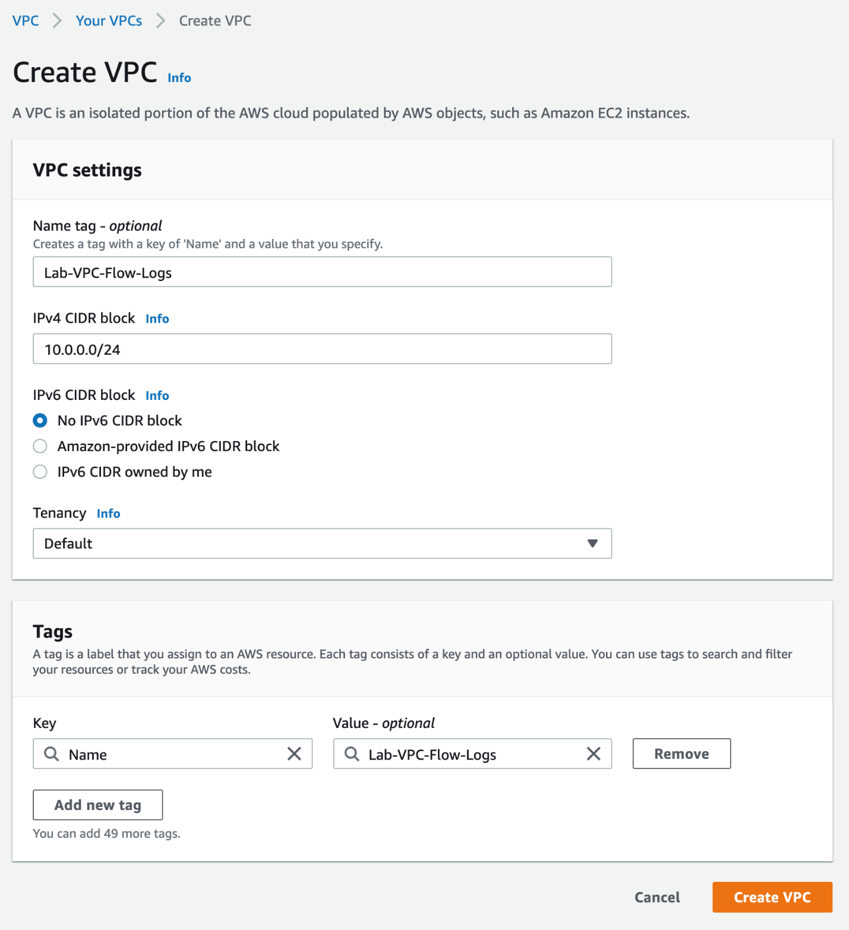

* 1. You should see that your VPC has been created successfully. Click on the **Your VPCs** link in the left sidebar to see the VPCs.

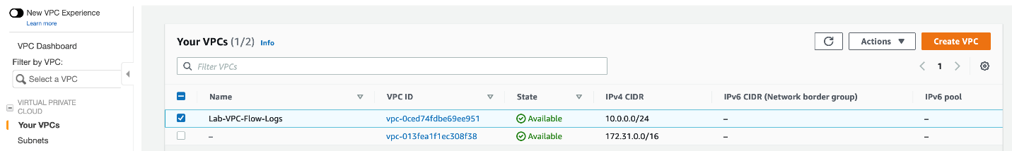

1. Now, we shall create a new subnet in this VPC.
   1. Click on the **Subnets** link in the left sidebar and then click **Create subnet** button.

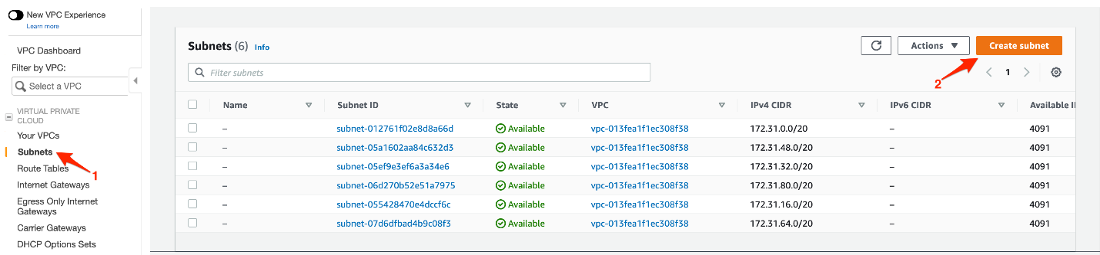

* 1. Enter the following values to create the subnet:

For **VPC ID**, select the VPC - **Lab-VPC-Flow-Logs**

**Subnet name:**Lab-VPC-Flow-Log-Subnet

For **Availability Zone**, select **us-east-1a**

**IPv4 CIDR block:**10.0.0.0/26

Click **Create subnet** to complete the configuration.

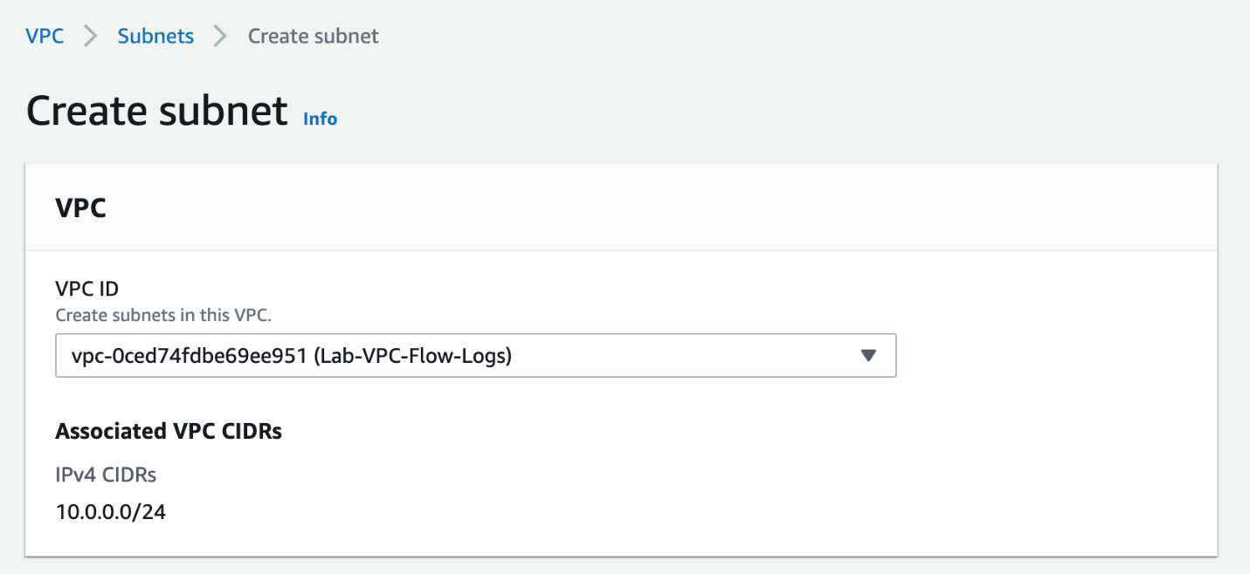

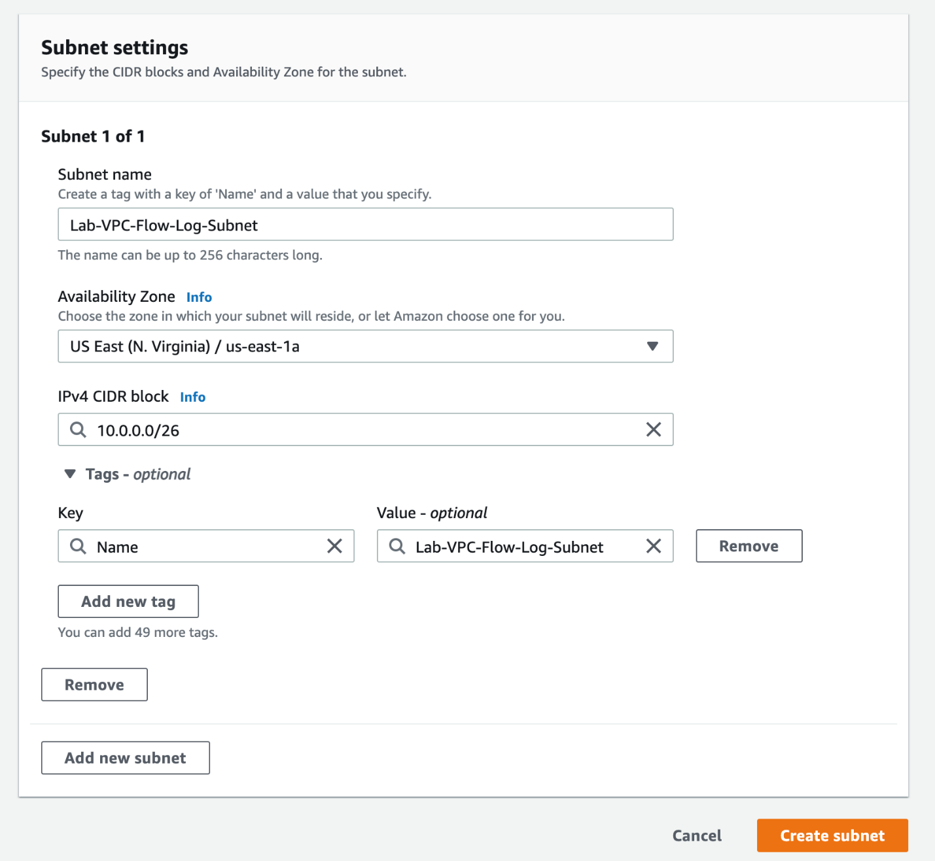

* 1. You should see that your subnet has been created successfully.

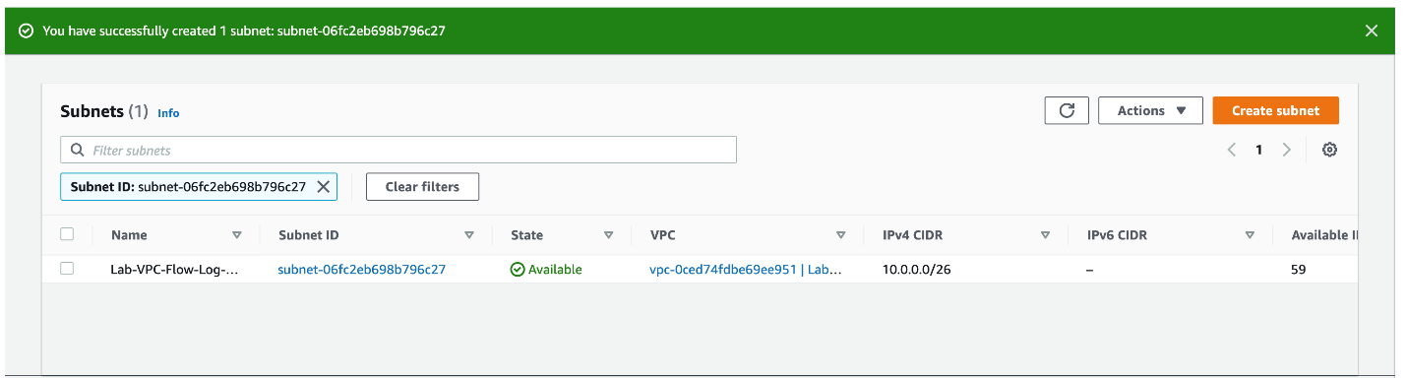

1. Lets create an Internet Gateway that will be attached to the VPC.
   1. Click on the **Internet Gateways** link in the left sidebar and then click **Create internet gateway** button.

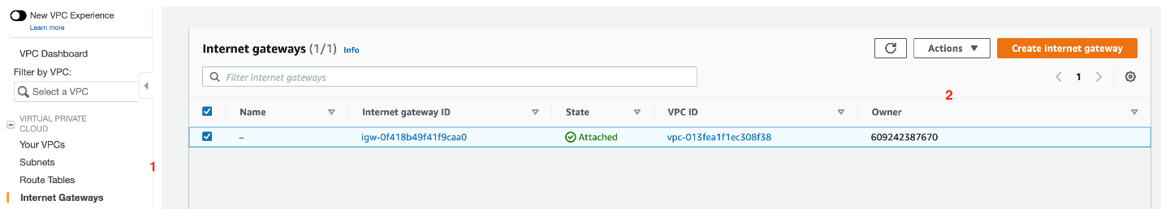

* 1. Enter the following values to create the internet gateway:

**Name tag**: Lab-VPC-Flow-Log-IG

Click **Create internet gateway** to complete the configuration.

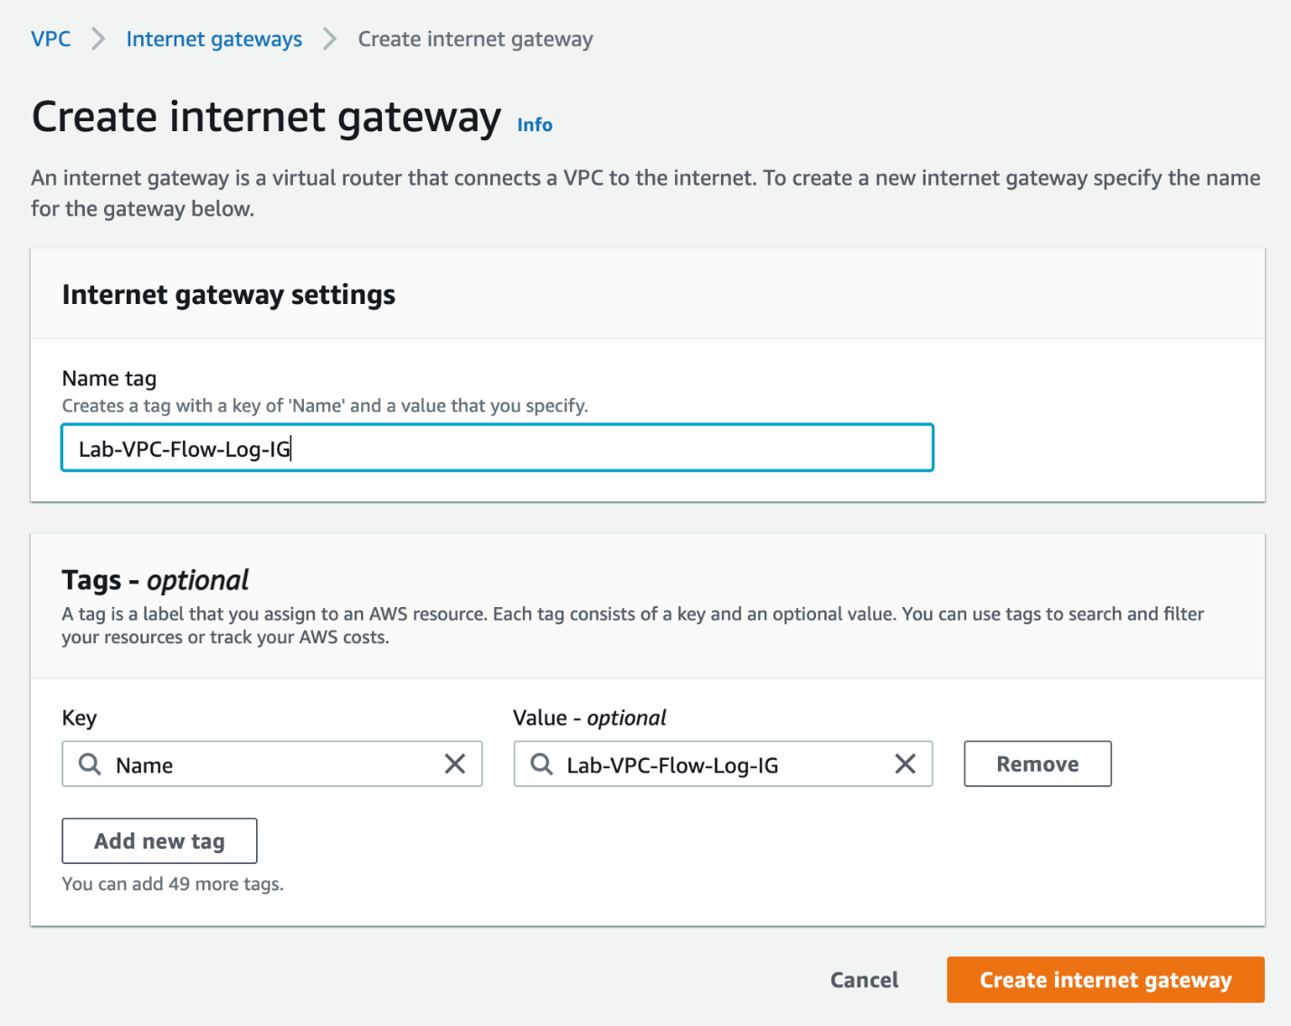

* 1. You should see that your internet gateway has been created successfully. Click on **Attach to VPC** from the **Actions** menu.

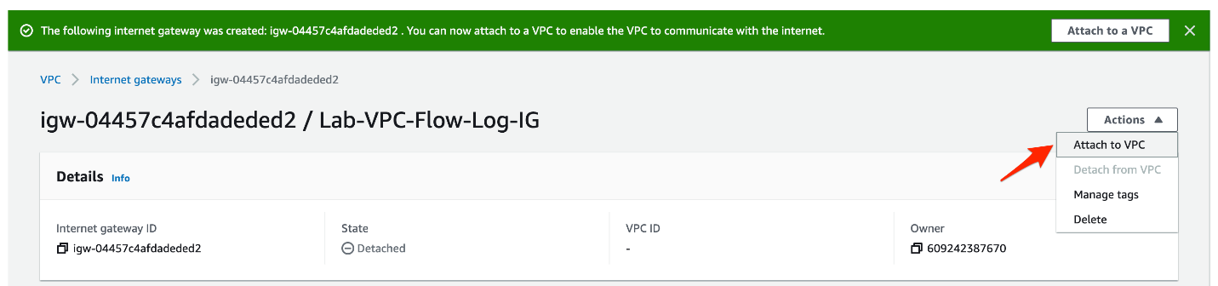

* 1. Select the VPC - **Lab-VPC-Flow-Logs**and click on the **Attach internet gateway** button.

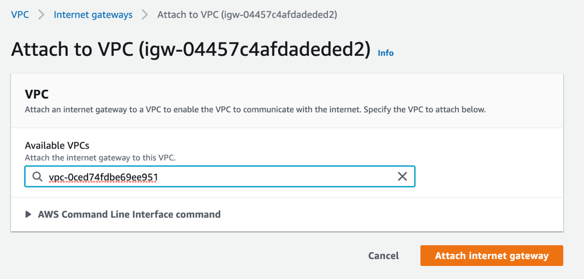

1. Now, we shall create a route for this internet gateway in the main route table of the VPC.
   1. Click on the **Route Tables** link in the left sidebar and then select the main route table for your VPC - **Lab-VPC-Flow-Logs**. Select the **Routes** tab and click on the **Edit routes** button.

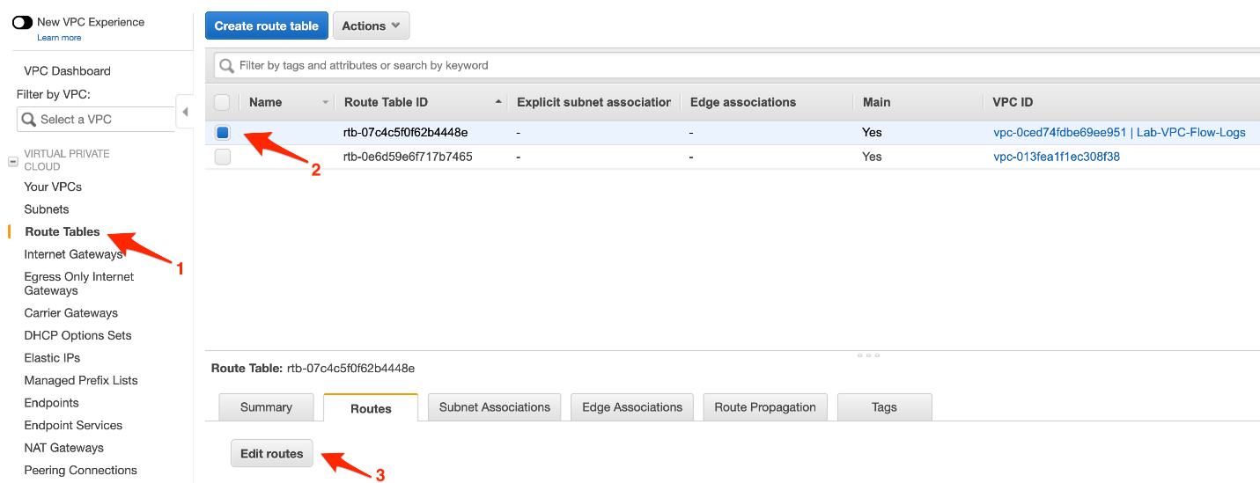

* 1. Click on the **Add route** button and enter **destination** as 0.0.0.0/0, select the internet gateway - **Lab-VPC-Flow-Log-IG**- as the **target**. Click on the **Save routes** button.

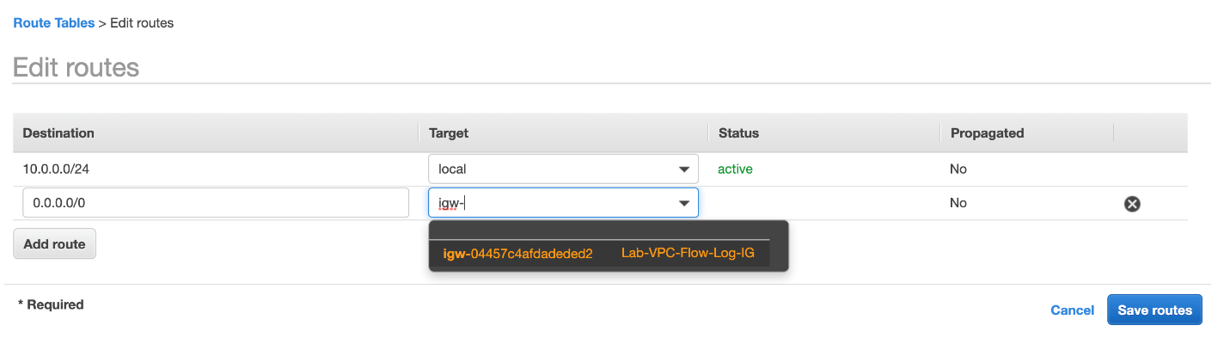

* 1. You should see that the route to the internet gateway has been added successfully.

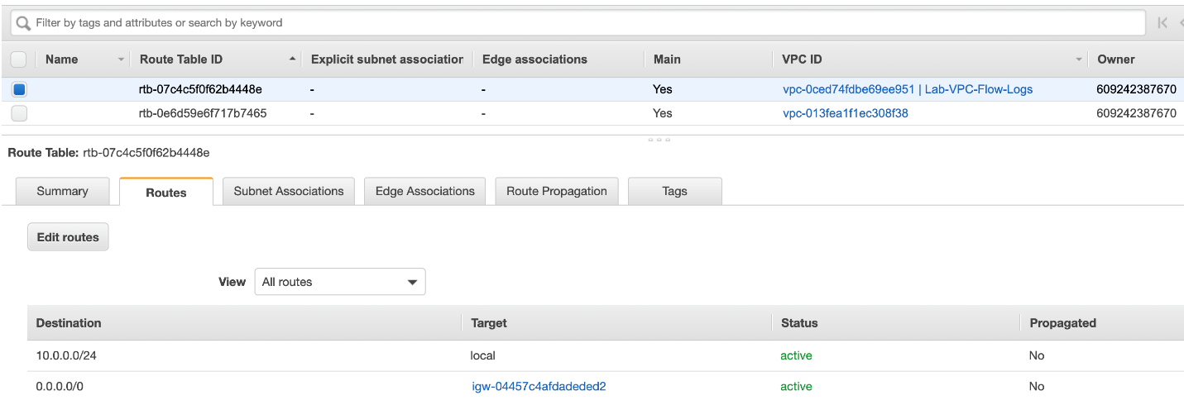

<https://docs.aws.amazon.com/vpc/latest/userguide/how-it-works.html>

<https://docs.aws.amazon.com/vpc/latest/userguide/VPC_Route_Tables.html>

<https://docs.aws.amazon.com/vpc/latest/userguide/VPC_Internet_Gateway.html>

Create VPC Flow Logs with destination as Cloudwatch Logs and S3

You need to configure two separate VPC Flow Logs for the VPC created in the task above. The first VPC Flow Log will have the destination as CloudWatch Logs that can be used to create a metric filter and then create a CloudWatch alarm using this metric filter. The alarm will be triggered when a forbidden traffic event is detected. This in turn will send an email via SNS notifications. The second VPC Flow Log will have the destination as an S3 bucket which will be used for analytics by leveraging Amazon Athena.

1. Make sure that you are in the N.Virginia AWS Region on the AWS Management Console. Enter **CloudWatch** in the search bar and select **CloudWatch**service.

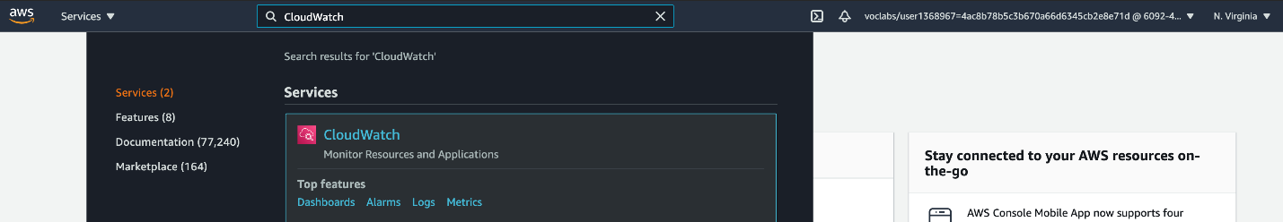

1. Lets create the CloudWatch log group which will be used as a destination for the VPC Flow Log.
   1. Click on **Logs** from the left sidebar. Click on the **Create log group** button.

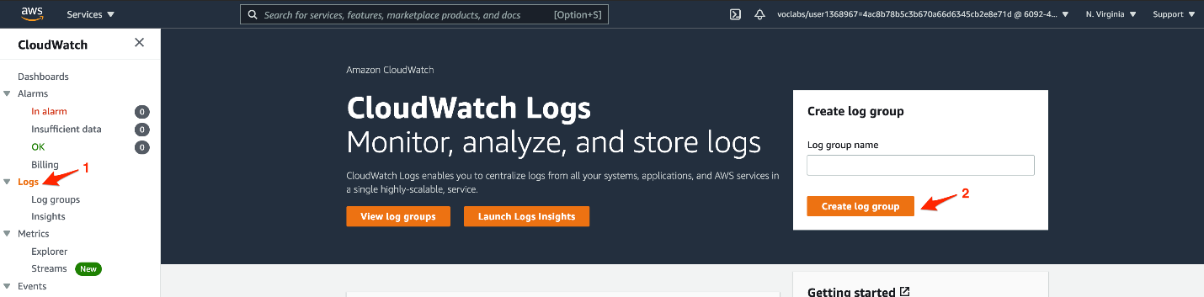

* 1. Enter the following values to create the CloudWatch log group:

**Log group name**: Lab-VPC-Flow-Log-Group

Select **Retention setting** as **Never expire**

Click on **Create** button

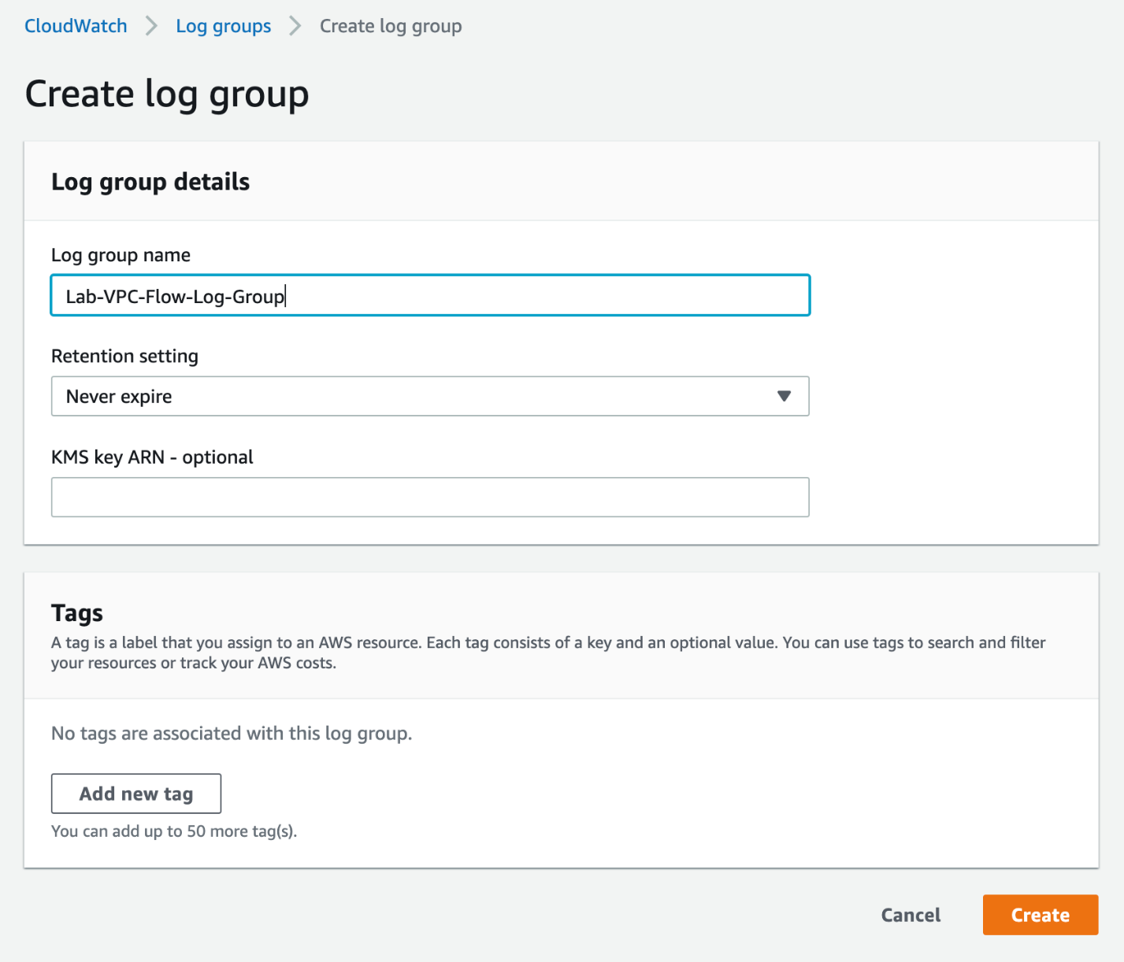

* 1. You should see that the log group has been created successfully.

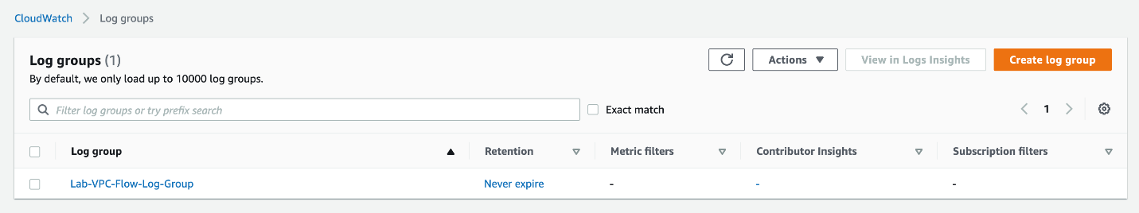

1. Navigate to the **VPC** service in the AWS Management Console.
   1. Select **Your VPCs** on the left sidebar and then click on the link for the VPC ID for your VPC - **Lab-VPC-Flow-Logs**.

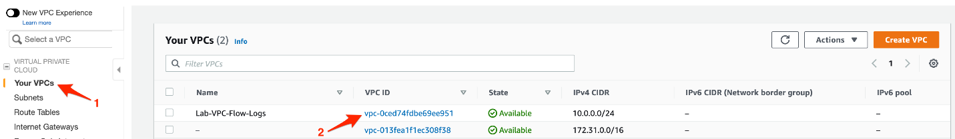

* 1. Select the **Flow Logs** tab for the VPC and click on the **Create flow log** button.

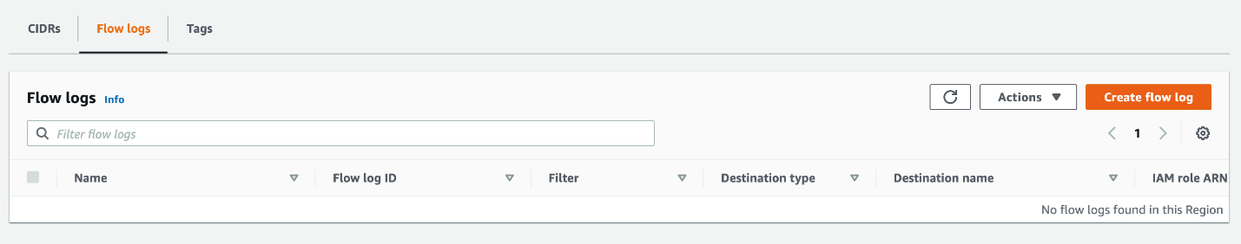

* 1. Enter the following values to create the VPC flow log:

**Name**: VPC-Flow-Log-Cloudwatch

For **Filter**, select **All**

For **Maximum aggregation interval**, select **1 minute**

For**Destination,**select**Send to Cloudwatch Logs**

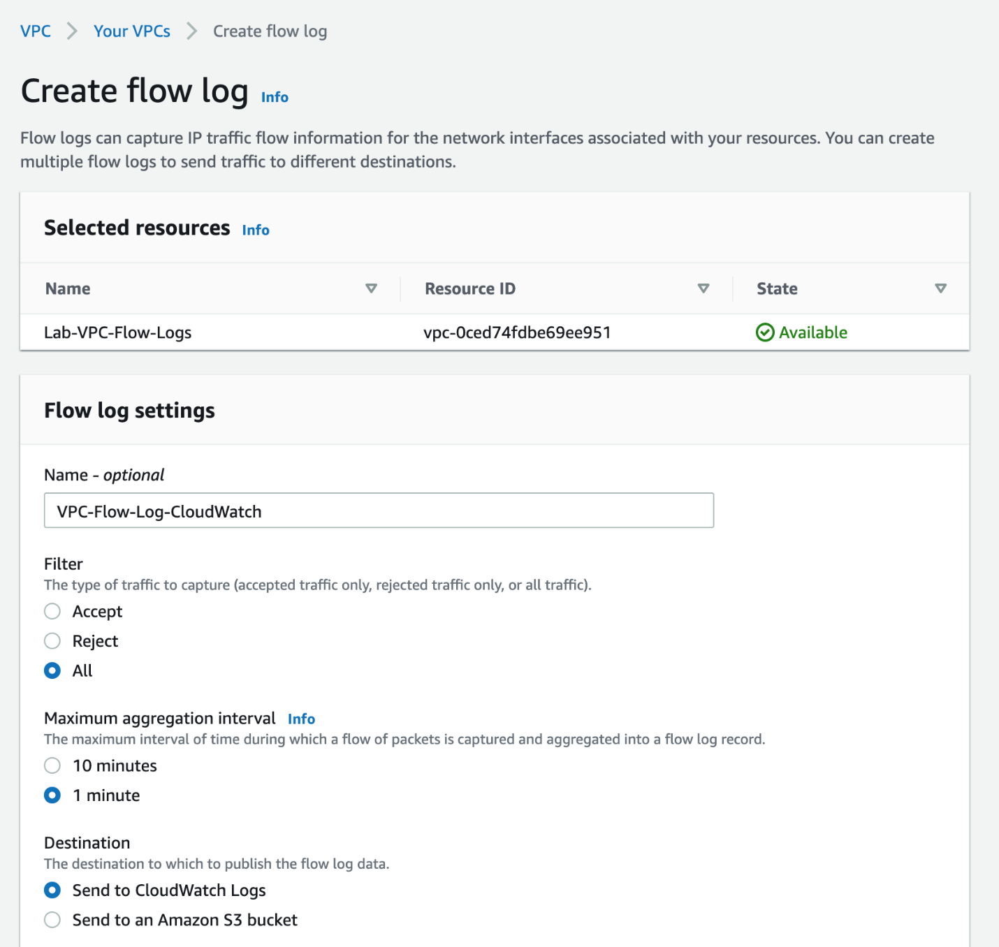

For **Destination log group**, select **Lab-VPC-Flow-Log-Group**

For**IAM role,**click on the**Set up permissions**link

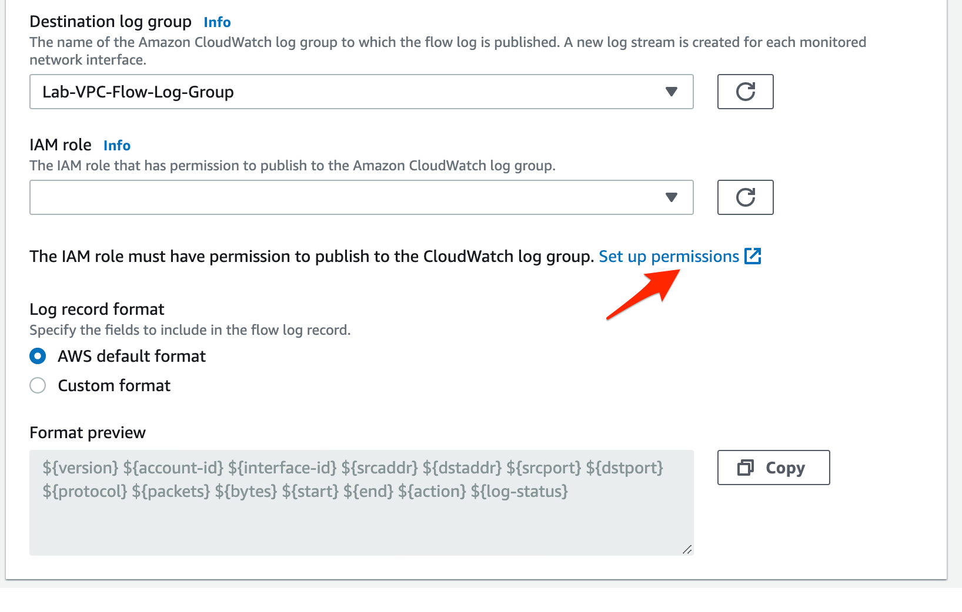

The link would open in a new browser window. Keep the default values and click on the **Allow** button.

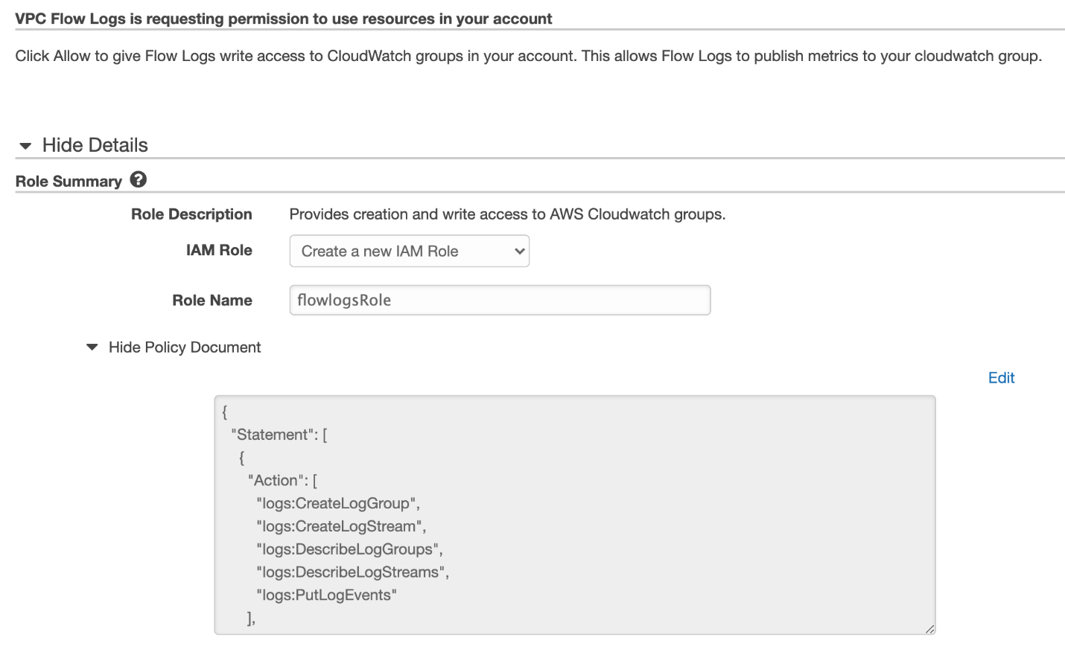

In the original browser window, click on the refresh icon next to the **IAM role** dropdown and you should be able to see the new role.

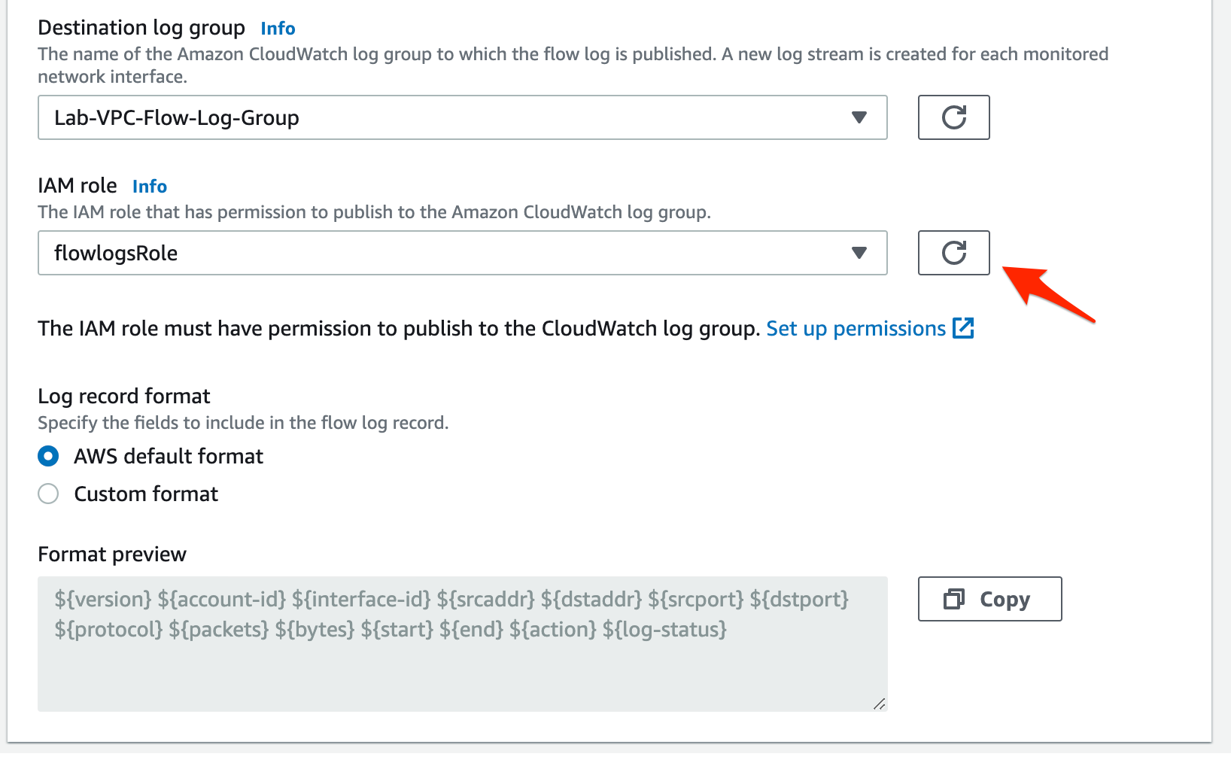

Keep the **Tags** values unchanged and click on the **Create flow log** button.

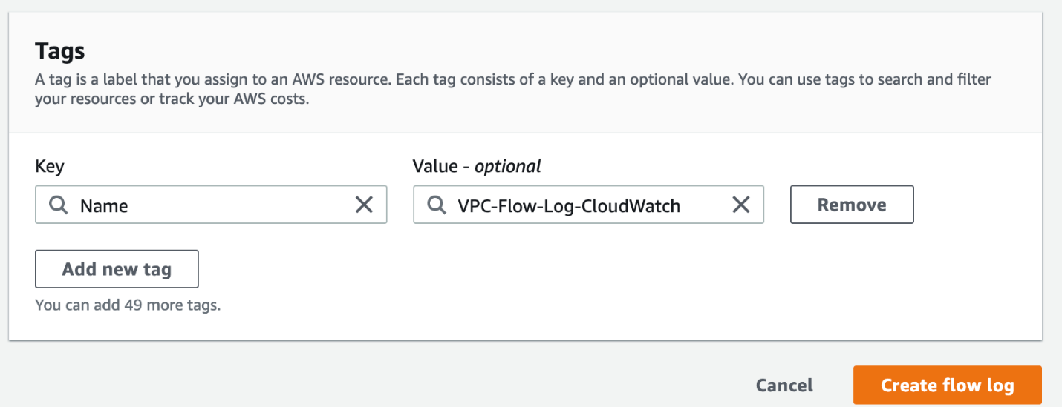

1. Now, you need to create an S3 bucket that will be used as a destination for the second VPC Flow Log.
   1. Navigate to the **S3** service in the AWS Management Console.

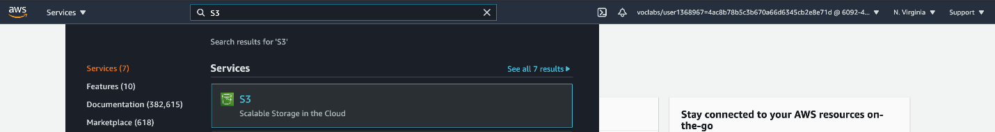

* 1. Click on the **Buckets** link on the left sidebar and then click on the **Create bucket** button

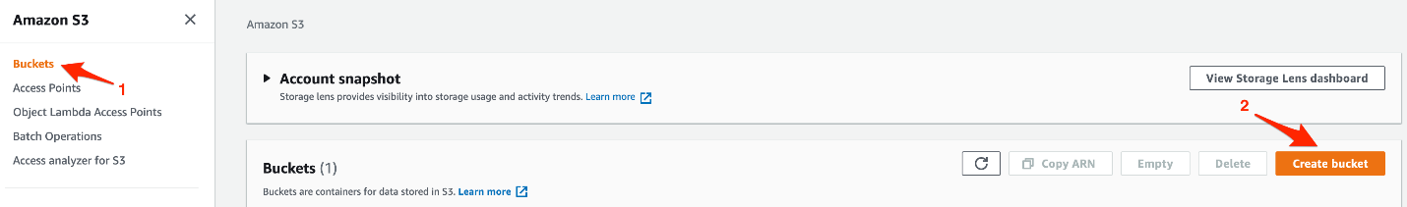

* 1. Enter the following values to create the bucket:

**Bucket name**: lab-vpc-flow-log-bucket (You will need to select a different name as S3 bucket names must be globally unique)

For **AWS Region**, select **US East (N. Virginia) us-east-1**

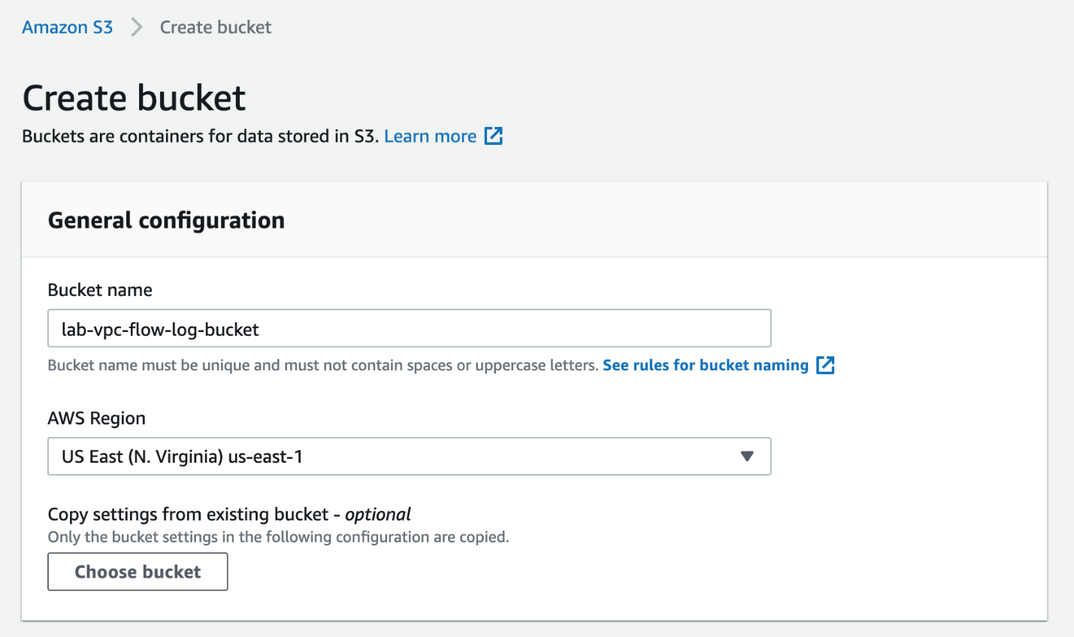

Keep all other values unchanged and click on the **Create bucket** button at the bottom of the screen.

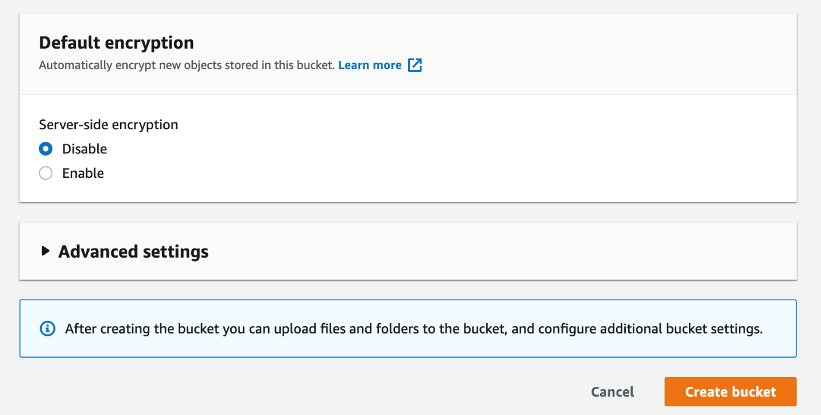

You should see that the S3 bucket has been created successfully.

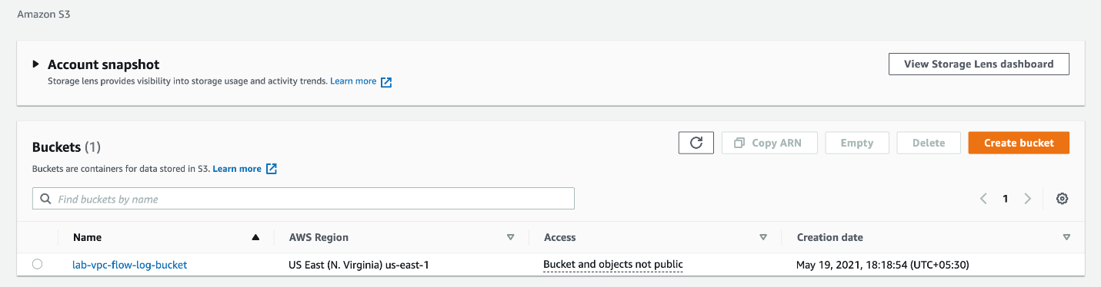

Click on the bucket name, go to the **Properties** tab and copy the bucket ARN which will be used in the next step while creating the VPC flow log.

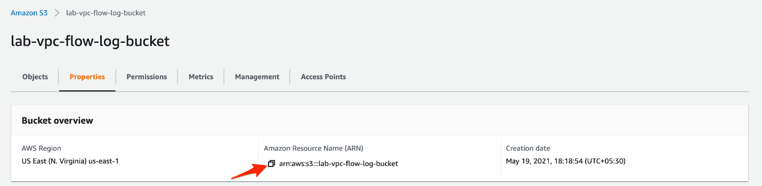

1. Lets create the second VPC FLow Log which will have the destination as S3 bucket.
   1. Navigate to the **VPC** service on AWS Management Console and select the VPC that you already created. Select the**Flow Logs** tab and then click on the **Create flow log** button.

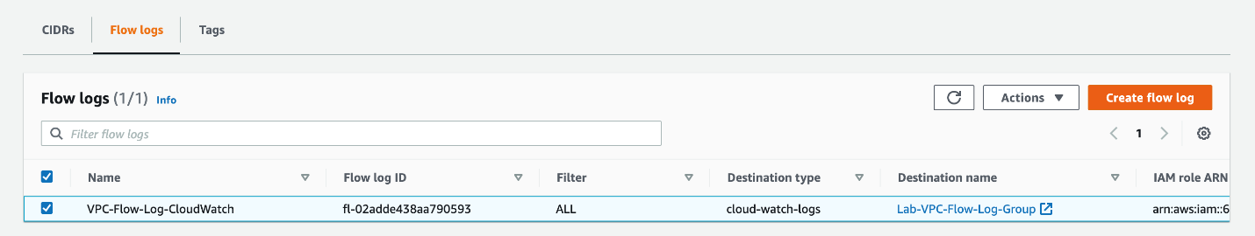

* 1. Enter the following values to create the VPC flow log:

**Name**: Lab-VPC-Flow-Log-S3

For **Filter**, select **All**

For **Maximum aggregation interval**, select **1 minute**

For**Destination,**select**Send to Amazon S3 bucket**

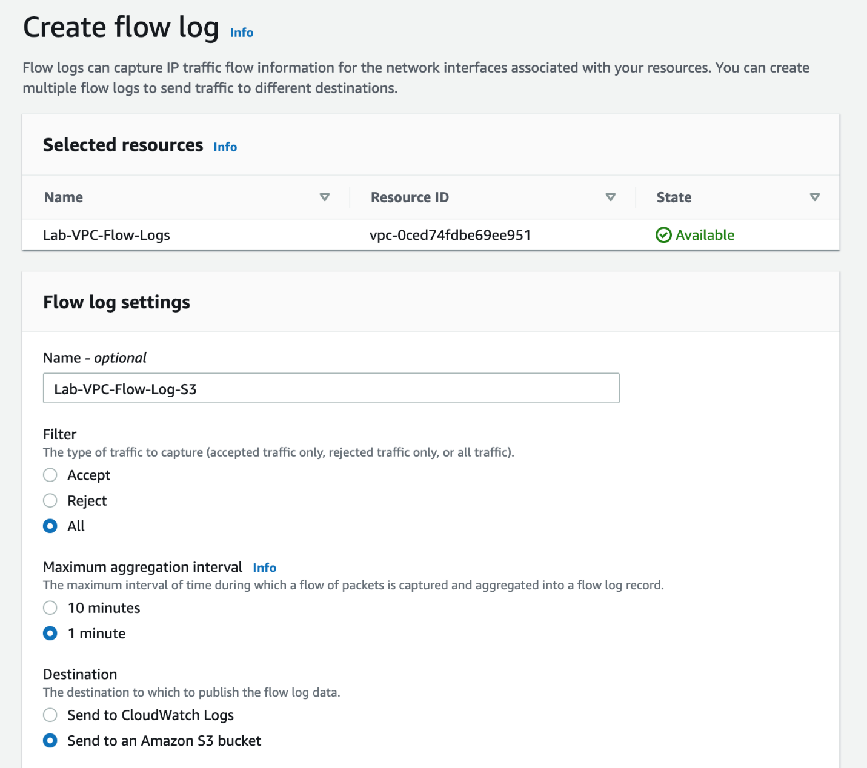

Paste the value for the **S3 bucket ARN** that you copied earlier and click on **Create flow log** button.

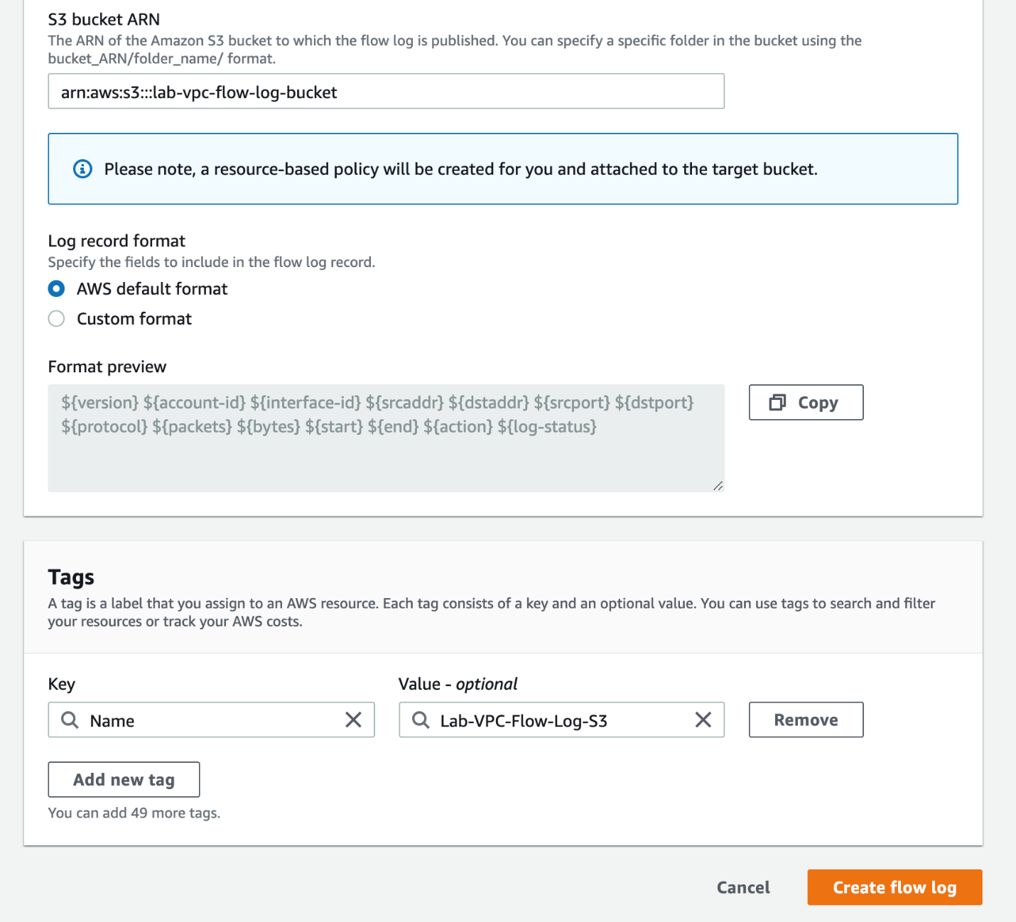

You should see that the second VPC flow log has also been created successfully.

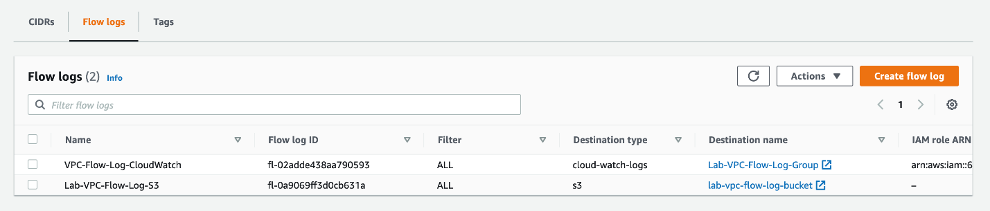

<https://docs.aws.amazon.com/AmazonCloudWatch/latest/logs/Working-with-log-groups-and-streams.html>

<https://docs.aws.amazon.com/vpc/latest/userguide/flow-logs.html>

<https://aws.amazon.com/blogs/aws/vpc-flow-logs-log-and-view-network-traffic-flows/>

Provision an EC2 to capture traffic logs into the VPC flow logs

### Tasks

### 0/6

### 1. Create VPC and its sub-resources to facilitate VPC Flow Logs

To implement this step, you need to set up a new VPC and then create a public subnet in this VPC. You will provision an Internet Gateway and make route entries for the Internet Gateway in the main Route Table for the given VPC.

1. Make sure that you are in the N.Virginia AWS Region on the AWS Management Console. Enter **VPC** in the search bar and select **VPC**service.



1. Lets create a new VPC that will be used to create the VPC Flow Log in a subsequent task.
   1. Click on the **Your VPCs** link in the left sidebar and then click **Create VPC** button



* 1. Enter the following values to create the VPC:

**Name-tag:** Lab-VPC-Flow-Logs

**IPv4 CIDR Block:** 10.0.0.0/24

For **IPv6 CIDR Block**, select **No IPv6 CIDR Block**

For **Tenancy**, select **Default** as the value

Click **Create VPC** to complete the configuration.



* 1. You should see that your VPC has been created successfully. Click on the **Your VPCs** link in the left sidebar to see the VPCs.



1. Now, we shall create a new subnet in this VPC.
   1. Click on the **Subnets** link in the left sidebar and then click **Create subnet** button.



* 1. Enter the following values to create the subnet:

For **VPC ID**, select the VPC - **Lab-VPC-Flow-Logs**

**Subnet name:**Lab-VPC-Flow-Log-Subnet

For **Availability Zone**, select **us-east-1a**

**IPv4 CIDR block:**10.0.0.0/26

Click **Create subnet** to complete the configuration.





* 1. You should see that your subnet has been created successfully.



1. Lets create an Internet Gateway that will be attached to the VPC.
   1. Click on the **Internet Gateways** link in the left sidebar and then click **Create internet gateway** button.



* 1. Enter the following values to create the internet gateway:

**Name tag**: Lab-VPC-Flow-Log-IG

Click **Create internet gateway** to complete the configuration.



* 1. You should see that your internet gateway has been created successfully. Click on **Attach to VPC** from the **Actions** menu.



* 1. Select the VPC - **Lab-VPC-Flow-Logs**and click on the **Attach internet gateway** button.



1. Now, we shall create a route for this internet gateway in the main route table of the VPC.
   1. Click on the **Route Tables** link in the left sidebar and then select the main route table for your VPC - **Lab-VPC-Flow-Logs**. Select the **Routes** tab and click on the **Edit routes** button.



* 1. Click on the **Add route** button and enter **destination** as 0.0.0.0/0, select the internet gateway - **Lab-VPC-Flow-Log-IG**- as the **target**. Click on the **Save routes** button.



* 1. You should see that the route to the internet gateway has been added successfully.



## Resources

#### Documentation

* VPC and subnet basics
* Route tables for your VPC
* Internet gateways overview

Mark task as complete

Report issue

### 2. Create VPC Flow Logs with destination as CloudWatch Logs and S3

You need to configure two separate VPC Flow Logs for the VPC created in the task above. The first VPC Flow Log will have the destination as CloudWatch Logs that can be used to create a metric filter and then create a CloudWatch alarm using this metric filter. The alarm will be triggered when a forbidden traffic event is detected. This in turn will send an email via SNS notifications. The second VPC Flow Log will have the destination as an S3 bucket which will be used for analytics by leveraging Amazon Athena.

1. Make sure that you are in the N.Virginia AWS Region on the AWS Management Console. Enter **CloudWatch** in the search bar and select **CloudWatch**service.



1. Lets create the CloudWatch log group which will be used as a destination for the VPC Flow Log.
   1. Click on **Logs** from the left sidebar. Click on the **Create log group** button.



* 1. Enter the following values to create the CloudWatch log group:

**Log group name**: Lab-VPC-Flow-Log-Group

Select **Retention setting** as **Never expire**

Click on **Create** button



* 1. You should see that the log group has been created successfully.



1. Navigate to the **VPC** service in the AWS Management Console.
   1. Select **Your VPCs** on the left sidebar and then click on the link for the VPC ID for your VPC - **Lab-VPC-Flow-Logs**.



* 1. Select the **Flow Logs** tab for the VPC and click on the **Create flow log** button.



* 1. Enter the following values to create the VPC flow log:

**Name**: VPC-Flow-Log-Cloudwatch

For **Filter**, select **All**

For **Maximum aggregation interval**, select **1 minute**

For**Destination,**select**Send to Cloudwatch Logs**



For **Destination log group**, select **Lab-VPC-Flow-Log-Group**

For**IAM role,**click on the**Set up permissions**link



The link would open in a new browser window. Keep the default values and click on the **Allow** button.



In the original browser window, click on the refresh icon next to the **IAM role** dropdown and you should be able to see the new role.



Keep the **Tags** values unchanged and click on the **Create flow log** button.



1. Now, you need to create an S3 bucket that will be used as a destination for the second VPC Flow Log.
   1. Navigate to the **S3** service in the AWS Management Console.



* 1. Click on the **Buckets** link on the left sidebar and then click on the **Create bucket** button



* 1. Enter the following values to create the bucket:

**Bucket name**: lab-vpc-flow-log-bucket (You will need to select a different name as S3 bucket names must be globally unique)

For **AWS Region**, select **US East (N. Virginia) us-east-1**



Keep all other values unchanged and click on the **Create bucket** button at the bottom of the screen.



You should see that the S3 bucket has been created successfully.



Click on the bucket name, go to the **Properties** tab and copy the bucket ARN which will be used in the next step while creating the VPC flow log.



1. Lets create the second VPC FLow Log which will have the destination as S3 bucket.
   1. Navigate to the **VPC** service on AWS Management Console and select the VPC that you already created. Select the**Flow Logs** tab and then click on the **Create flow log** button.



* 1. Enter the following values to create the VPC flow log:

**Name**: Lab-VPC-Flow-Log-S3

For **Filter**, select **All**

For **Maximum aggregation interval**, select **1 minute**

For**Destination,**select**Send to Amazon S3 bucket**



Paste the value for the **S3 bucket ARN** that you copied earlier and click on **Create flow log** button.



You should see that the second VPC flow log has also been created successfully.



## Resources

#### Documentation

* Working with Log Groups and Log Streams
* VPC Flow Logs
* VPC Flow Logs – Log and View Network Traffic Flows

Mark task as complete

Report issue

### 3. Provision an EC2 instance to capture traffic logs into the VPC flow logs

You will need to provision an EC2 instance in the public subnet of the VPC that you have already created. You will also create a Security Group to allow SSH access into the instance.

1. Make sure that you are in the N.Virginia AWS Region on the AWS Management Console. Enter **EC2** in the search bar and select **EC2**service.

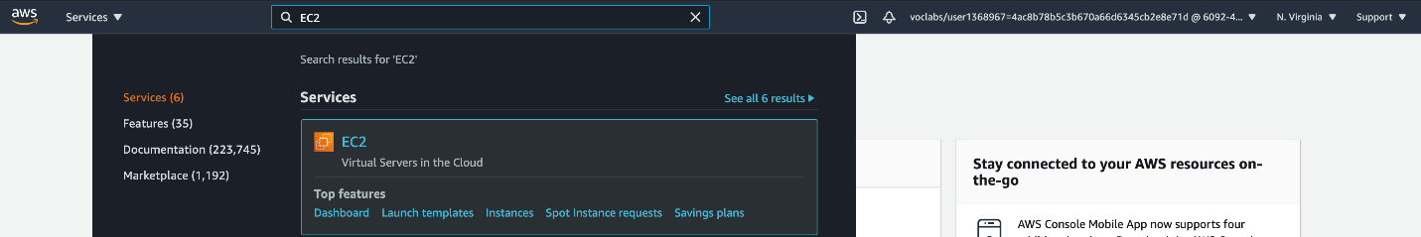

1. Lets create a security group to allow SSH into the EC2 instance.
   1. Select **Security Groups**from the left sidebar and click on **Create security group** button

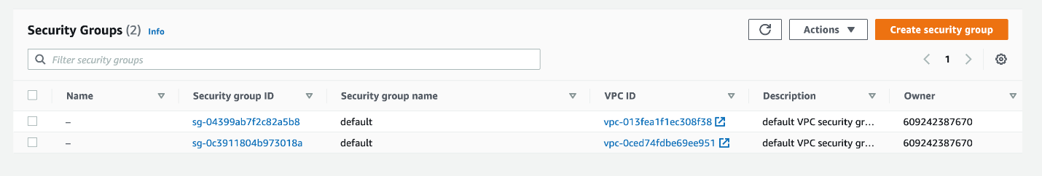

* 1. Enter the following values to create the security group:

**Security group name**: Lab-SSH

**Description**: Lab-SSH

For **VPC**, select **Lab-VPC-Flow-Logs**

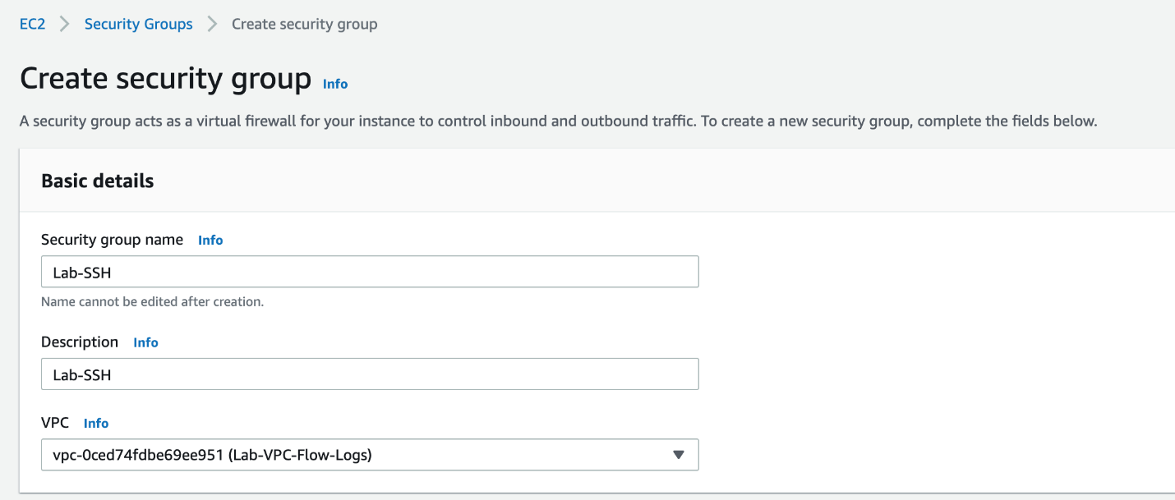

Click on **Add rule** button and configure values for the inbound rule for SSH access as shown below:

Type: SSH

Protocol: TCP

Port Range: 22

Source: Custom

Put the source IP value as 0.0.0.0/0

Note - For production systems, you should not have such open SSH access from any source. You should allow SSH only from your own public IP.

Click on Create security group

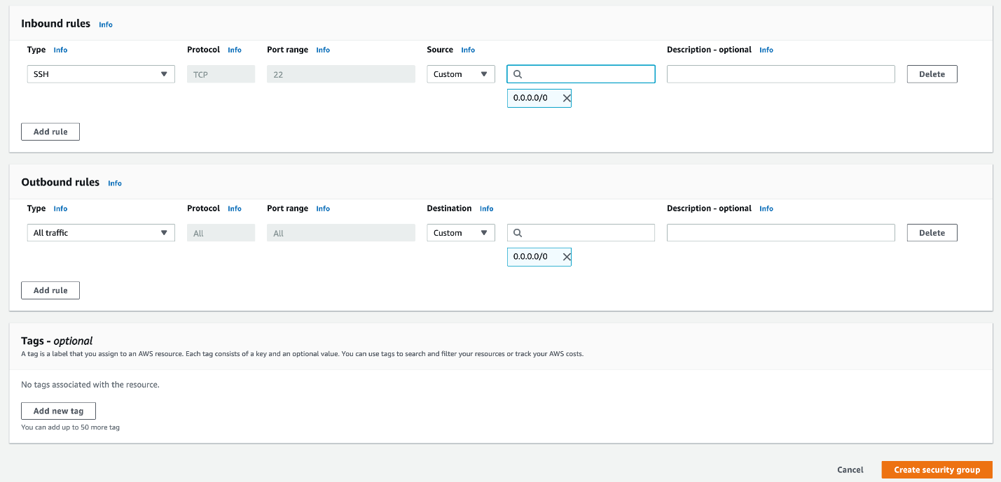

1. You should see that your security group has been created successfully.
2. 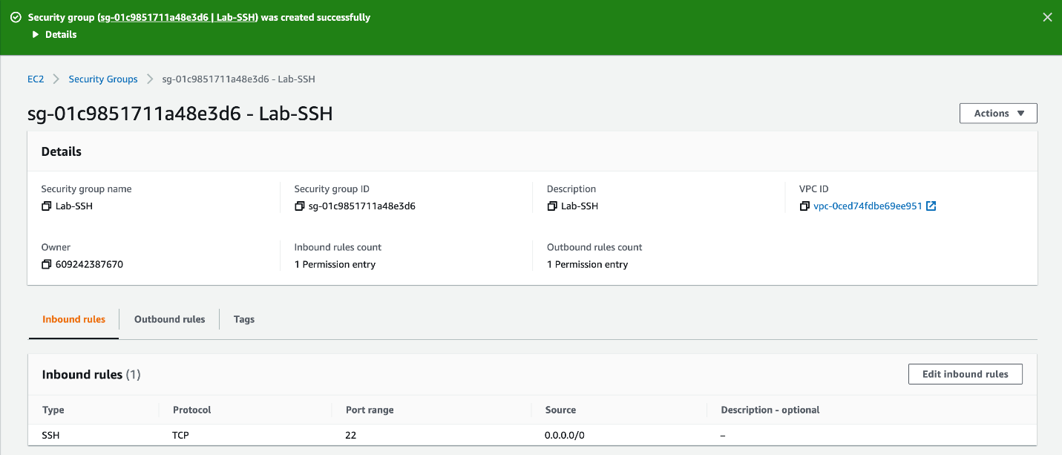
3. Now, we will provision the EC2 instance.
   1. Click on the **Instances** link on the left sidebar and click on the **Launch Instances** button.

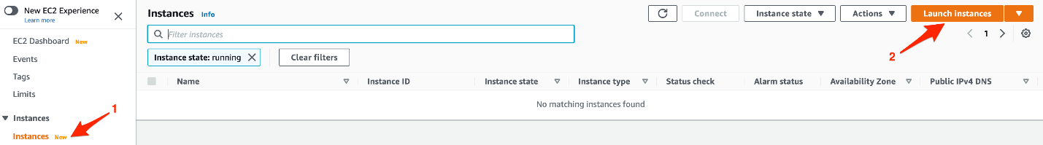

* 1. Choose **Amazon Linux 2 AMI** and click on Select.

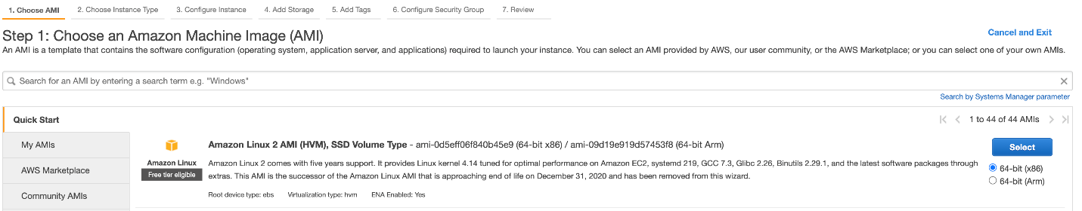

* 1. Choose **t2.micro** as the instance type and click on Next.

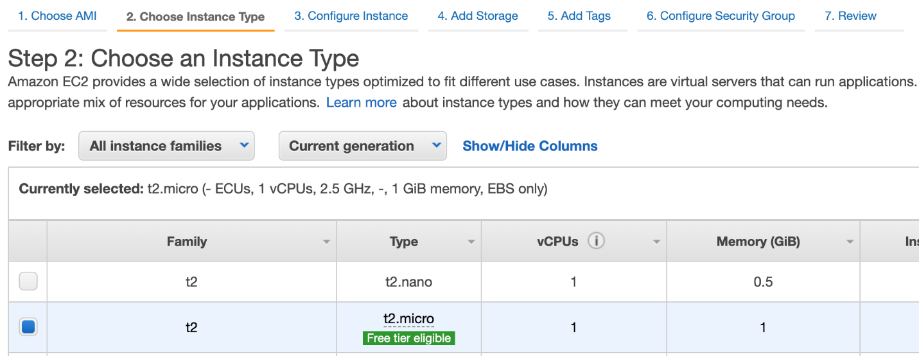

* 1. Configure instance details as follows:

Select **Lab-VPC-Flow-Logs** as the **Network**

Select**Lab-VPC-Flow-Log-Subnet**as the**Subnet**

For**Auto-assign Public IP,**select**Enable**

Select**IAM role**as**EMR_EC2_default**

Click on Next

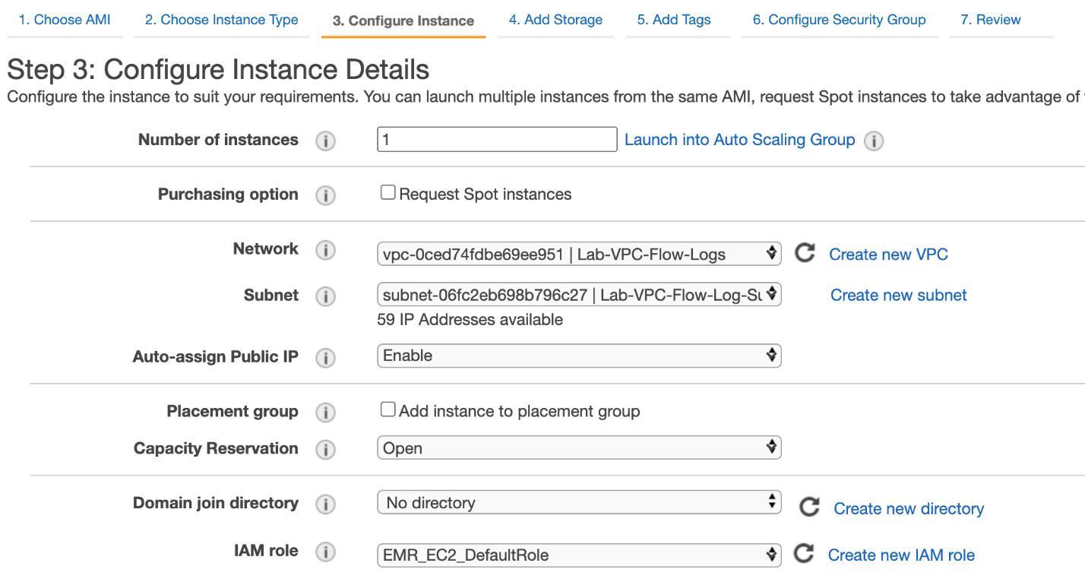

* 1. Leave the default values for **Add Storage** and click on Next.
  2. Leave the default values for **Add Tags** and click on Next.
  3. Configure the security group. Click on **Select an existing security group** and then select **Lab-SSH**security group

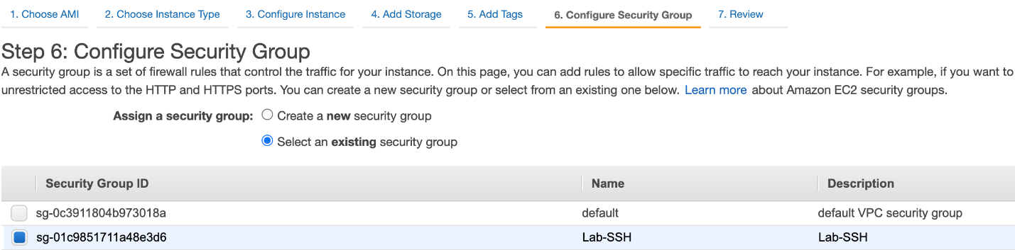

* 1. Review the instance launch details and then click on **Launch**button.

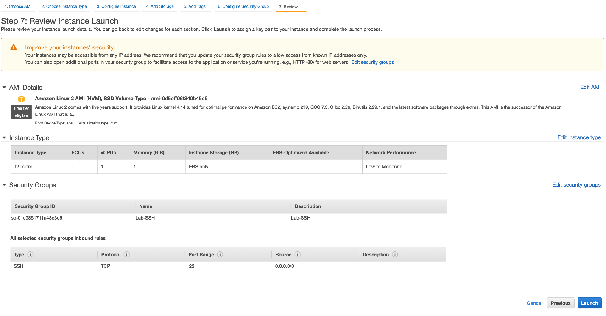

* 1. For the key pair, select **Proceed without a key pair** as we shall use EC2 Instance Connect to SSH into the instance. Select the checkbox for acknowledgement. Click on Launch Instance.

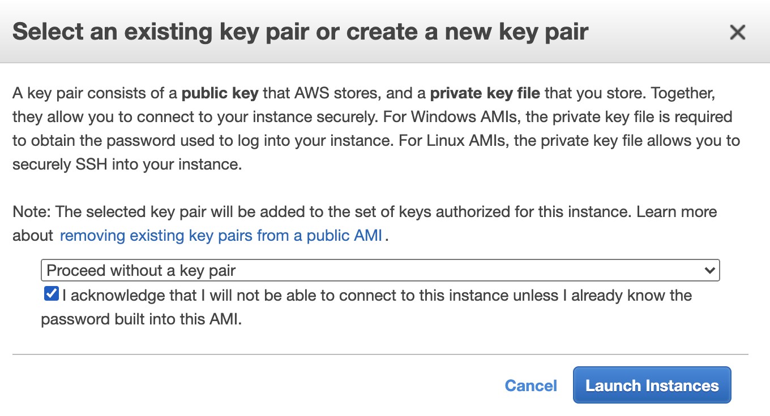

<https://docs.aws.amazon.com/vpc/latest/userguide/how-it-works.html>

<https://docs.aws.amazon.com/AWSEC2/latest/UserGuide/ec2-security-groups.html>

<https://docs.aws.amazon.com/AWSEC2/latest/UserGuide/concepts.html>

Configure CloudWatch metric-filter and cloudwatch alarm to monitor traffic

You will leverage CloudWatch metric filter and CloudWatch alarm to monitor AWS VPC Flow Logs that are ingested into CloudWatch Logs. To simulate forbidden traffic type, you will create an outbound deny rule for all ICMP traffic in the VPC NACL. You will then set up a metric filter that watches over any rejected pings from the EC2 instance. This metric filter is further linked to a CloudWatch alarm that sends out an email via SNS notifications whenever a rejected ping is detected.

1. Navigate to the EC2 service in the AWS Management Console.
   1. Click on **Instances** in the left sidebar and then select the EC2 instance you have already created. Click on the **Connect** button.

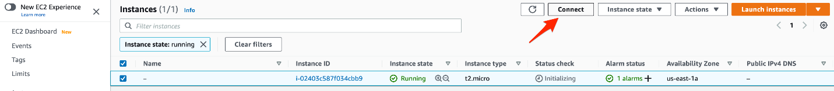

* 1. Select the **EC2 Instance Connect** tab and click on **Connect**.

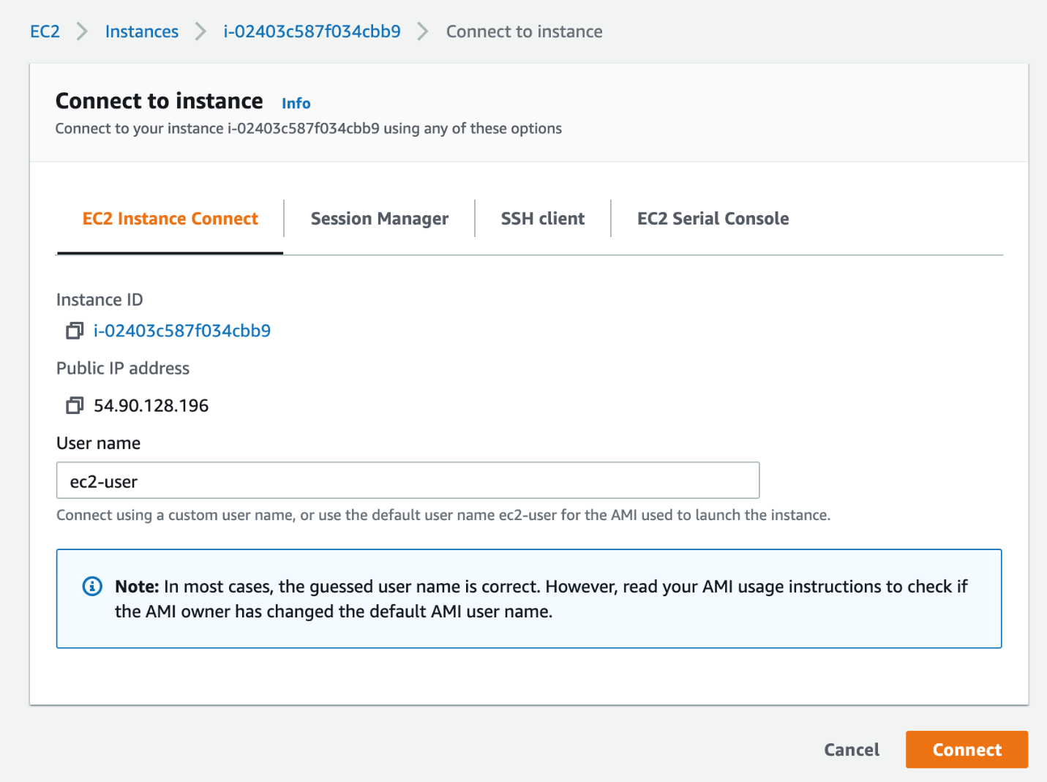

* 1. Lets send some traffic over the ICMP protocol by sending a ping to google.com. Type the command `ping google.com` on the terminal window and press Enter. Enter Ctrl+C after you receive a few packets. Also copy the IP address for google.com seen in the response (in this case, it is 172.217.2.110, as shown below)

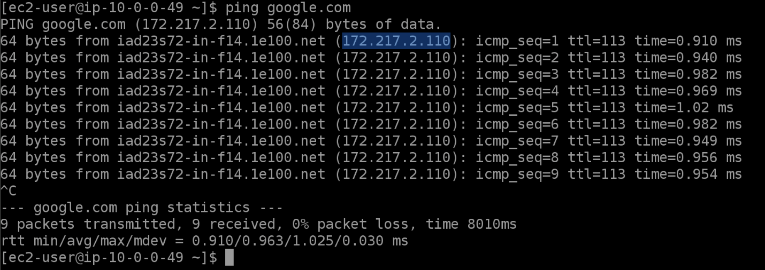

1. Navigate to the VPC service in the AWS Management Console.
   1. Select **Your VPCs** on the left sidebar and then click on the link for the VPC ID for your VPC - **Lab-VPC-Flow-Logs**.



* 1. Select the **Flow Logs** tab for the VPC and click on the destination CloudWatch Log link - **Lab-VPC-Flow-Log-Group**

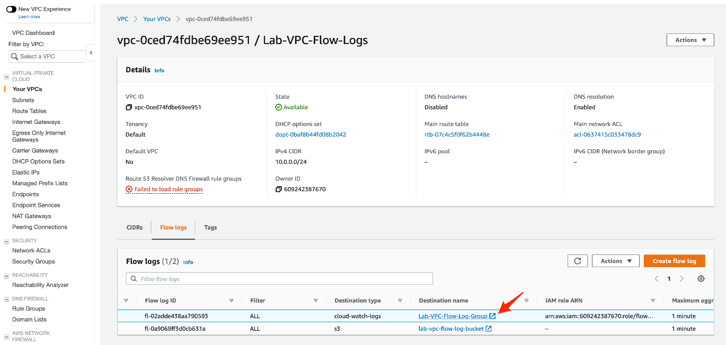

* 1. Click on the log stream for the ENI of the EC2 instance.

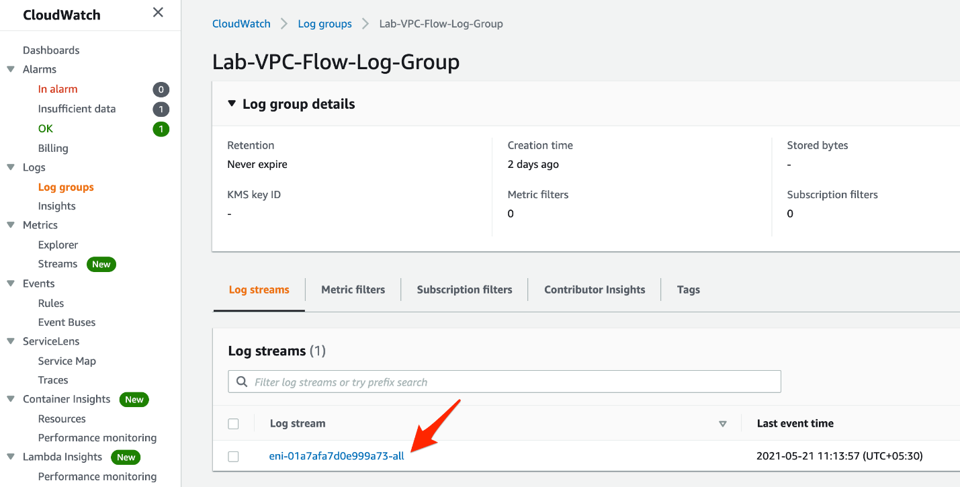

* 1. Search for the IP address (copied in Step 1) in the log events. You should see matching traffic records in the VPC flow log. You should also note that the entries are marked as **ACCEPT**.

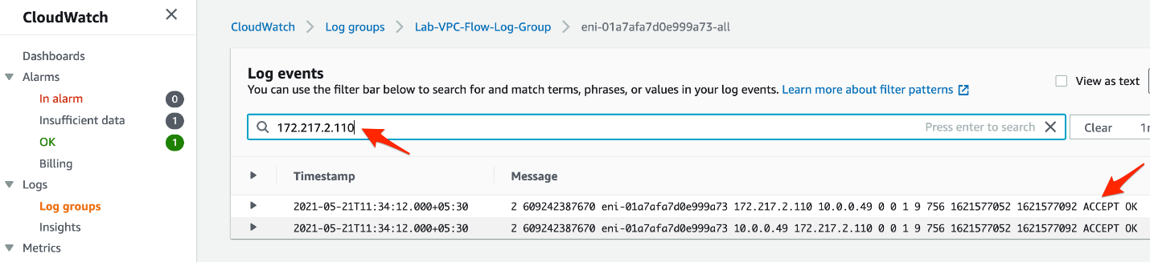

1. Navigate to the VPC service in the AWS Management Console.
   1. Click on the **Network ACLs** link in the left sidebar. Then click on the Network ACL ID for the subnet **Lab-VPC-Flow-Log-Subnet**.

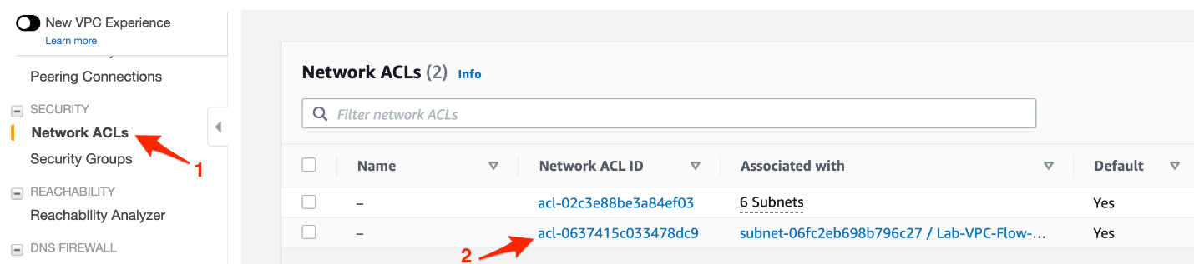

* 1. Select the **Outbound rules** tab and then click on the **Edit outbound rules** button.

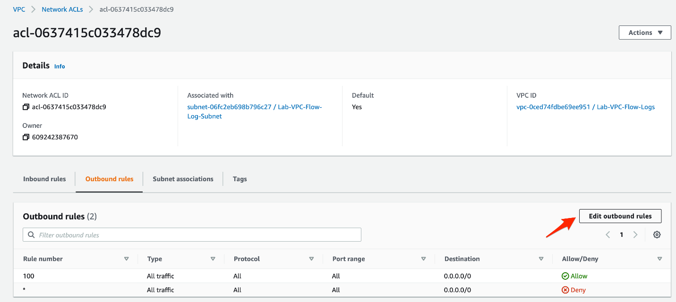

* 1. Click on the **Add new rule**button and enter the following values:

Rule number: 90

Type: All ICMP - Ipv4

Protocol: ICMP

Port range: All

Destination: 0.0.0.0/0

Allow/Deny: Deny

Click on **Sort by rule number** and finally **Save changes**.

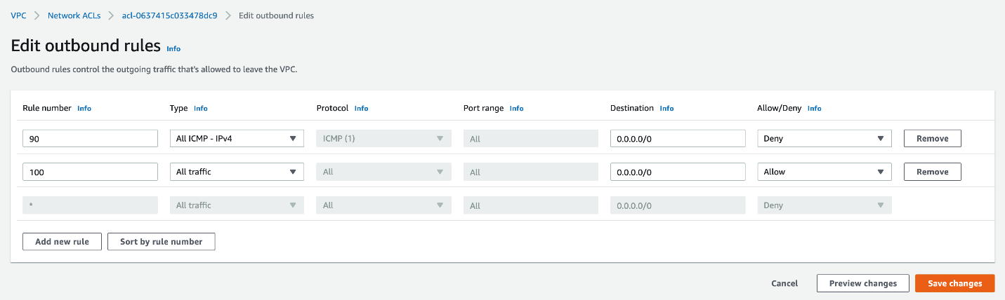

1. Navigate to the CloudWatch service in the AWS Management Console. Click on the **Log groups** link in the left sidebar and select the **Lab-VPC-Flow-Log-Group** log group.
   1. Select the **Metric filters** tab and click on the **Create metric filter** button.

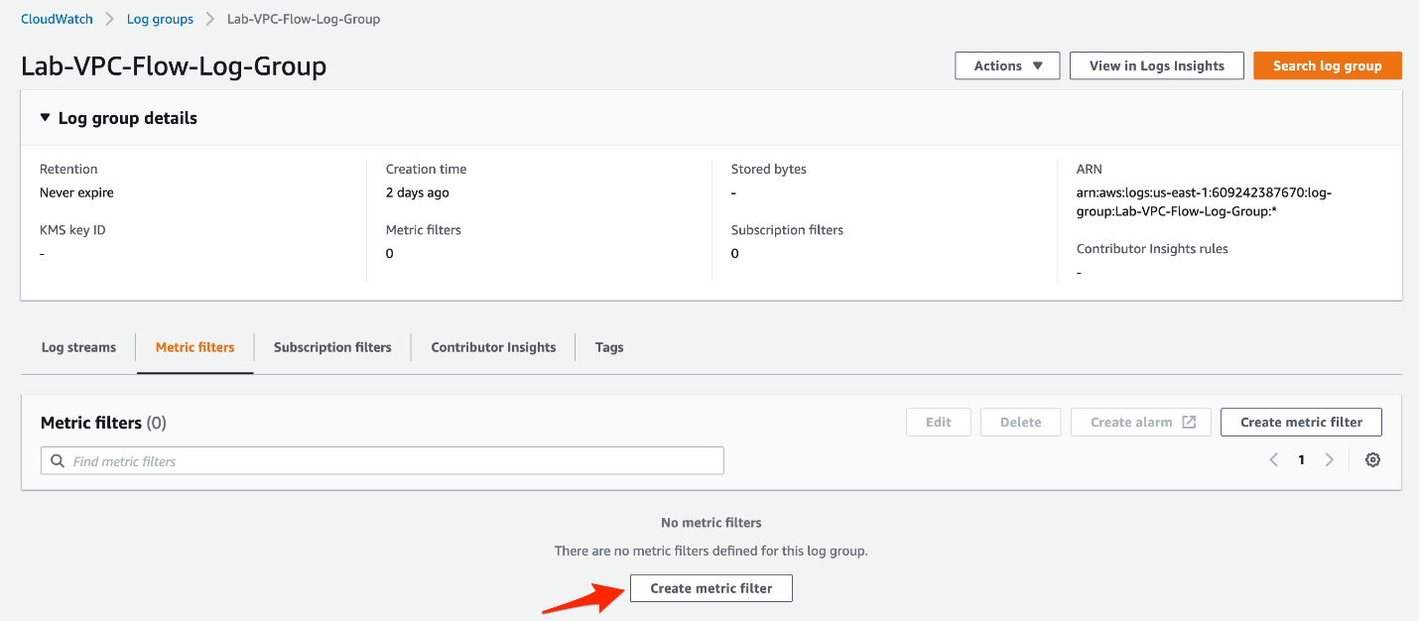

* 1. Enter the values for the filter pattern as follows:

**Filter pattern**:

[version, account, eni, source, destination, srcport, destport, protocol="1", packets, bytes, starttime, endtime, action="REJECT", flowlogstatus]

For the Test pattern, select **Custom log data** as the log data to test. Then enter the following log event messages:

* + 1. 2 609242387670 eni-01a7afa7d0e999a73 10.0.0.49 172.217.9.206 0 0 1 33 2772 1621577928 1621577987 REJECT OK
    2. 2 609242387670 eni-01a7afa7d0e999a73 18.206.107.25 10.0.0.49 19653 22 6 70 7047 1621576794 1621576852 ACCEPT OK
    3. 2 609242387670 eni-01a7afa7d0e999a73 10.0.0.49 18.206.107.25 22 19653 6 57 9761 1621576794 1621576852 ACCEPT OK
    4. 2 609242387670 eni-01a7afa7d0e999a73 10.0.0.49 172.217.12.208 0 0 1 33 2775 1621577938 1621577998 REJECT OK

Click on the **Test pattern** button and it should show the rejected results. Then click on the **Next**button.

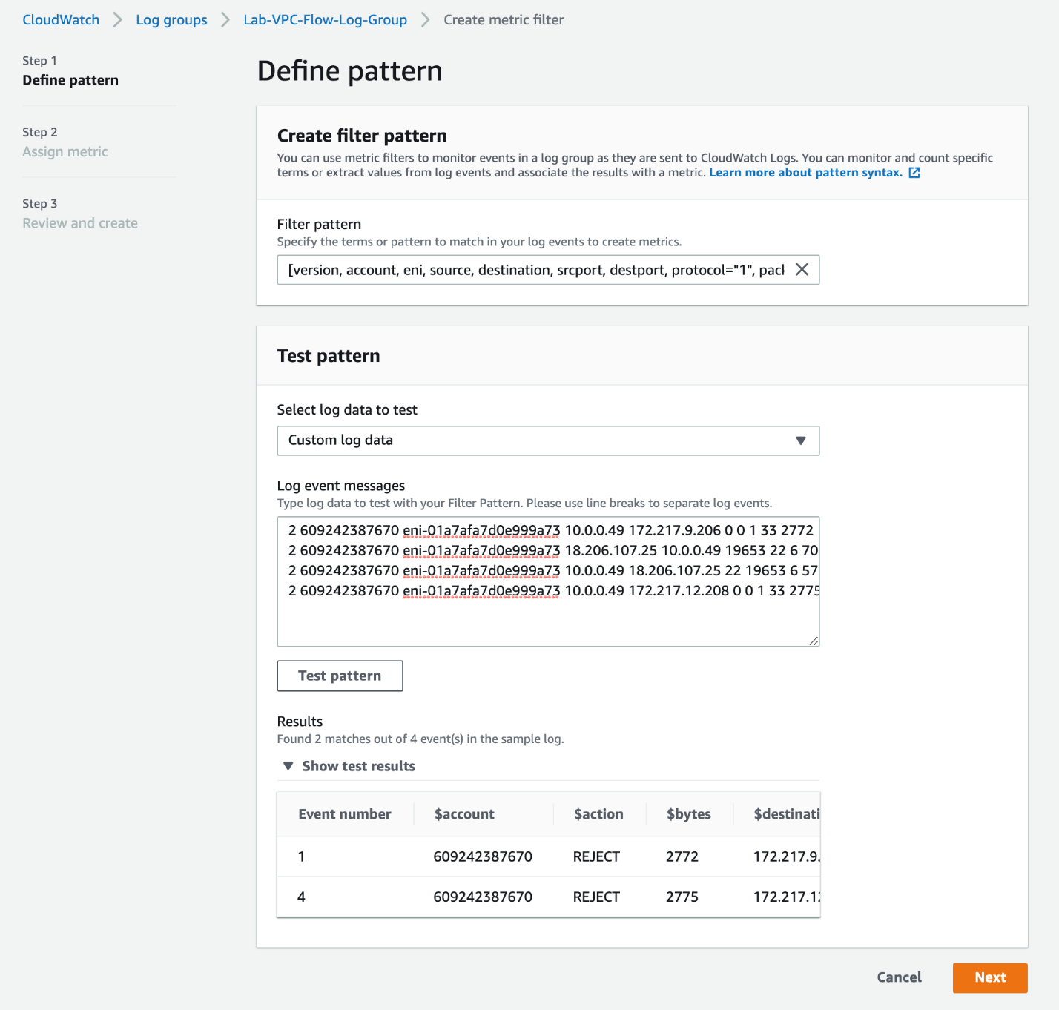

* 1. Assign metric values as shown below:

**Filter name**: Lab-VPC-Flow-Log-Ping-Deny

**Metric namespace**: Lab-VPC-Flow-Log-Ping

**Metric name**: Ping-Deny

**Metric value**: 1

Click on the **Next**button.

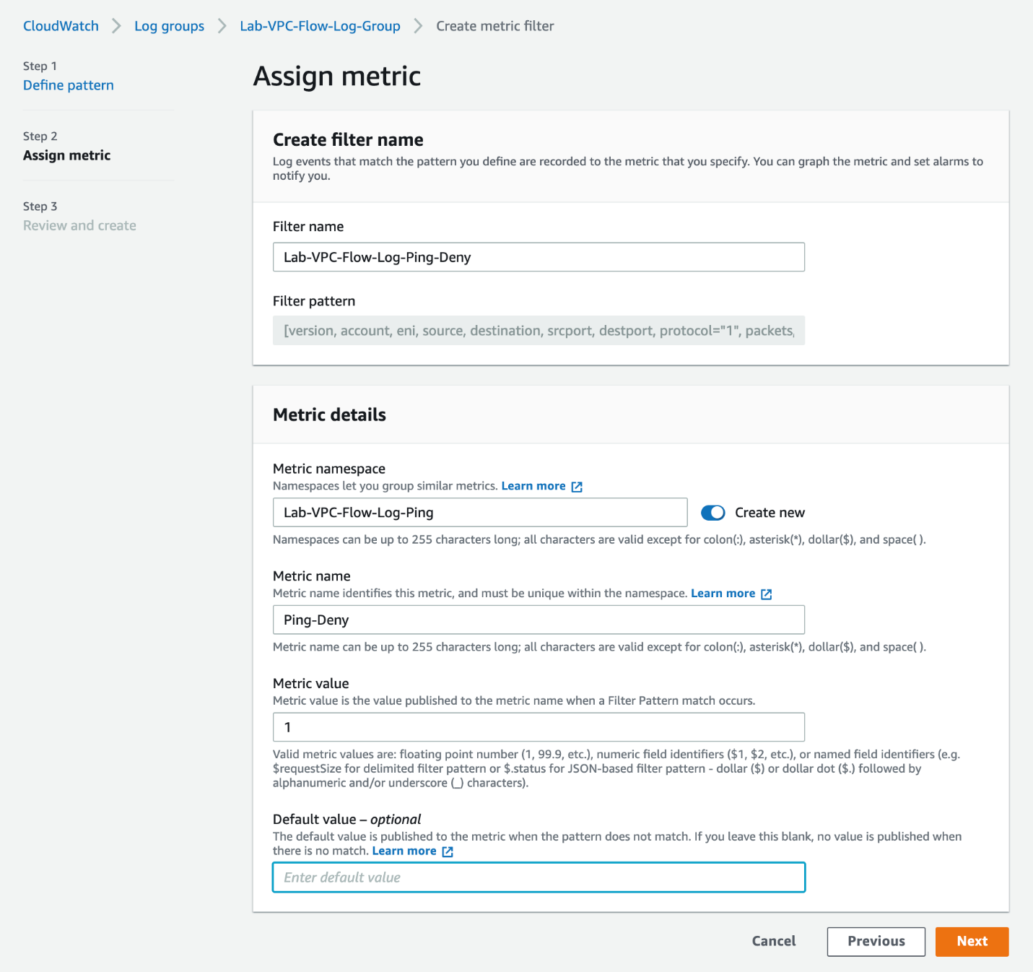

* 1. Review and click on **Create metric filter**.

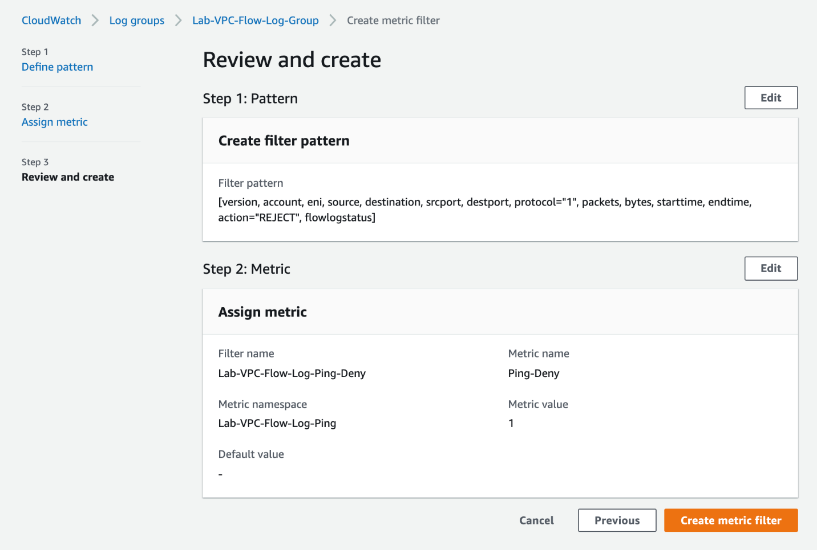

* 1. Select the checkbox for the metric-filter **Lab-VPC-Flow-Log-Ping-Deny** and then click on the **Create alarm** button.

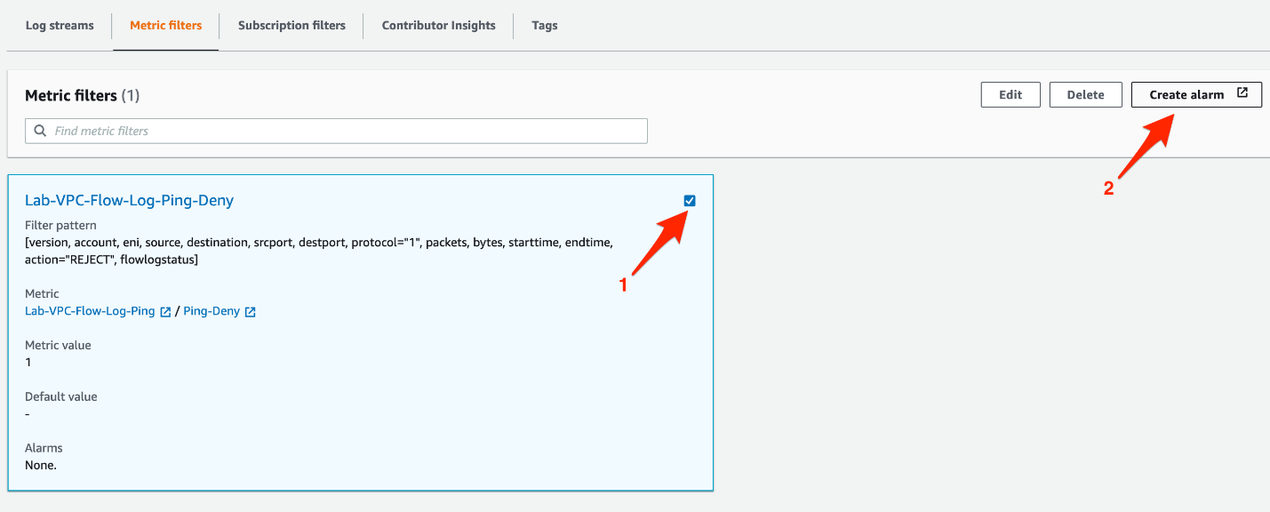

* 1. Enter values for the alarm metric and conditions:

**Metric-name**: Ping-Deny

For **Statistic**, select **Sum**

For **Period**, select **1 minute**

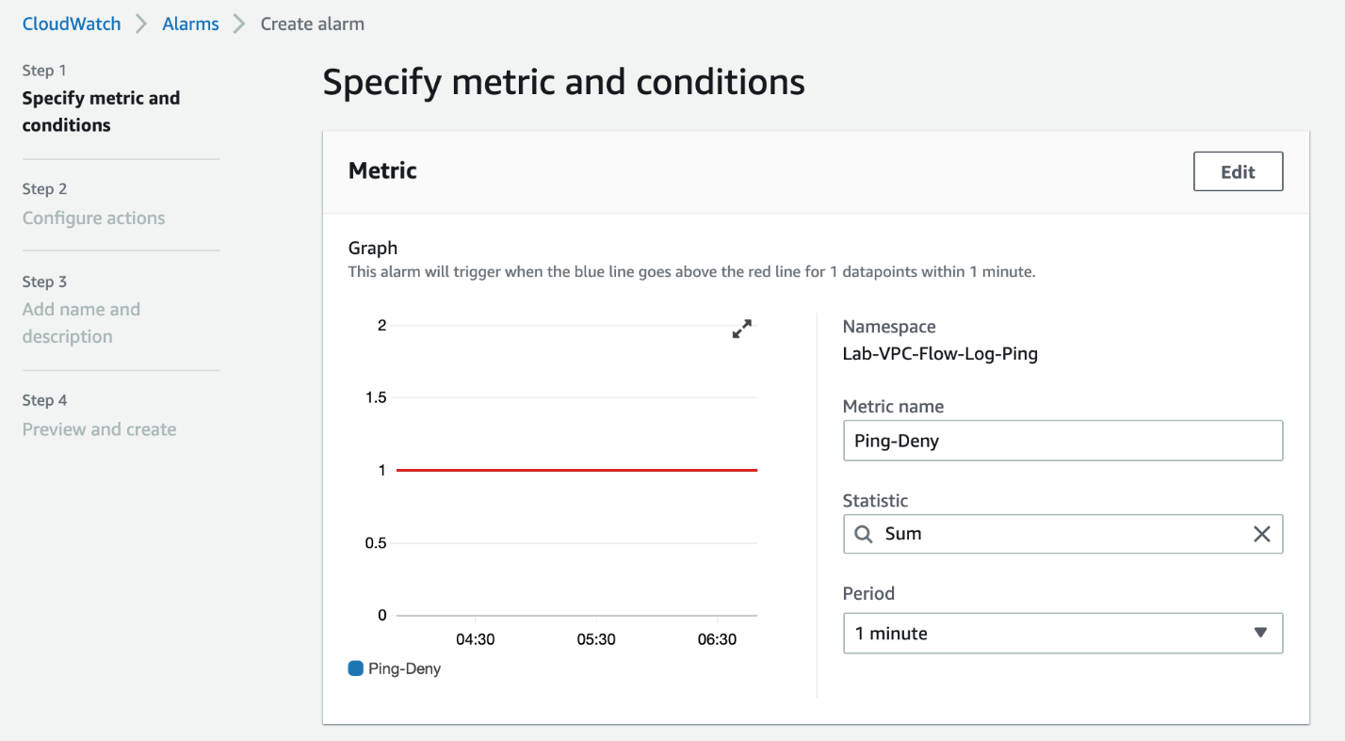

For the **Conditions** section, select **Static** as the **Threshold type**, select **alarm condition** as **Greater/Equal** and enter **threshold value** as **1**. Click on **Next** to proceed.

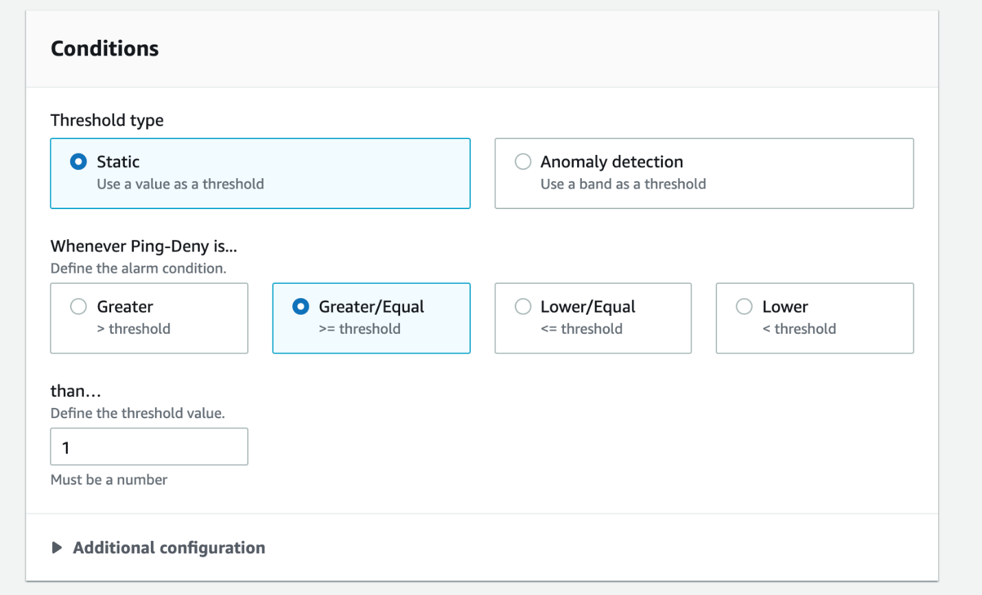

* 1. Enter values for the alarm action:

For the **Alarm state trigger**, select **In alarm**

For the**SNS topic,**select**Create new topic**

Enter**CloudWatch_Alarms_Ping_Deny**as the name for the new topic

Enter your email address as the **email endpoint**

Click on **Create Topic**button and then click on **Next**button at the bottom of the screen.

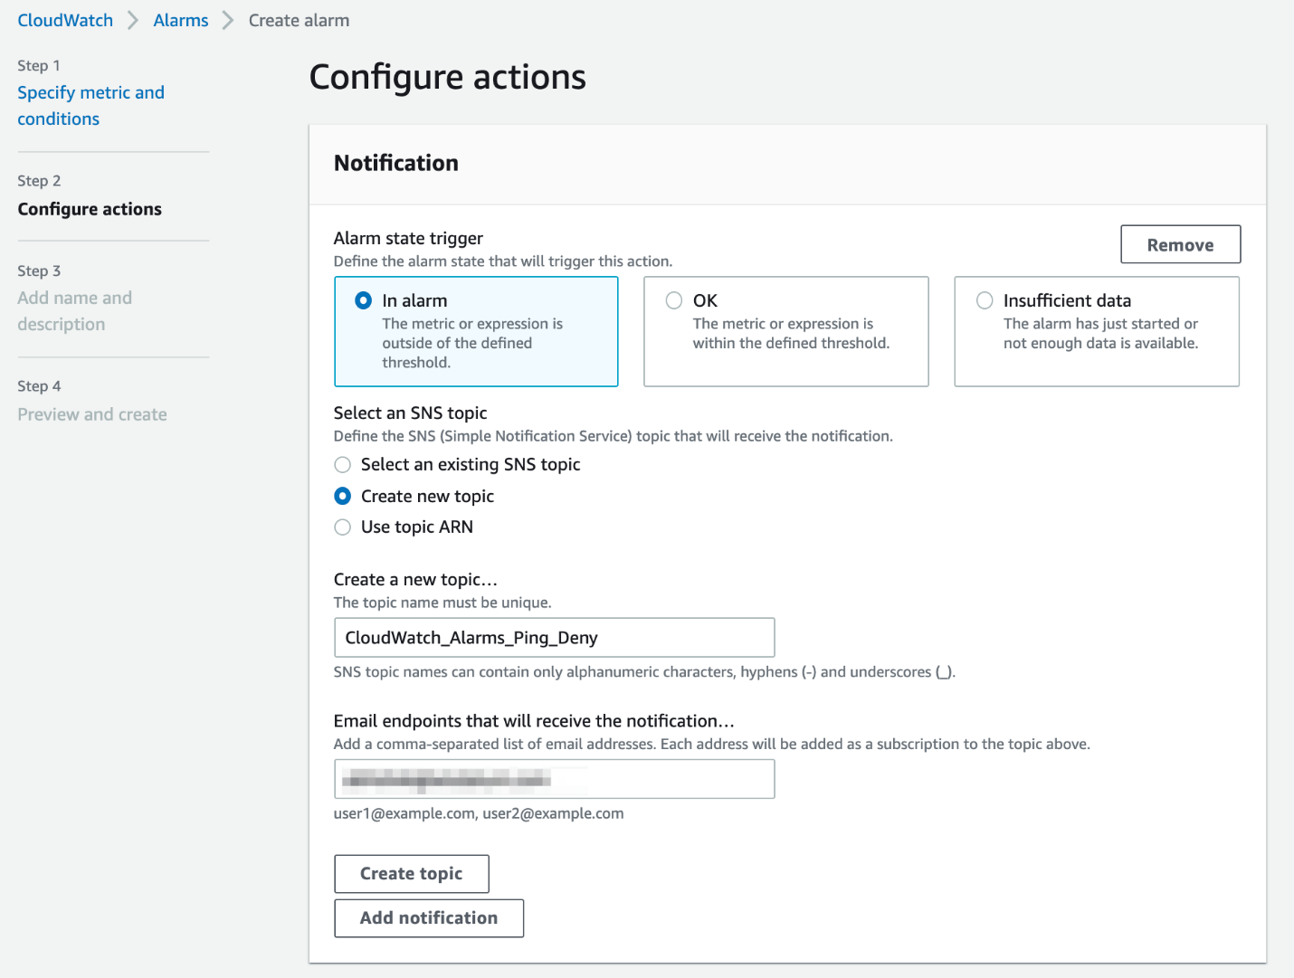

* 1. Enter **CloudWatch-Alarm-Ping-Deny** as the **Alarm name**.

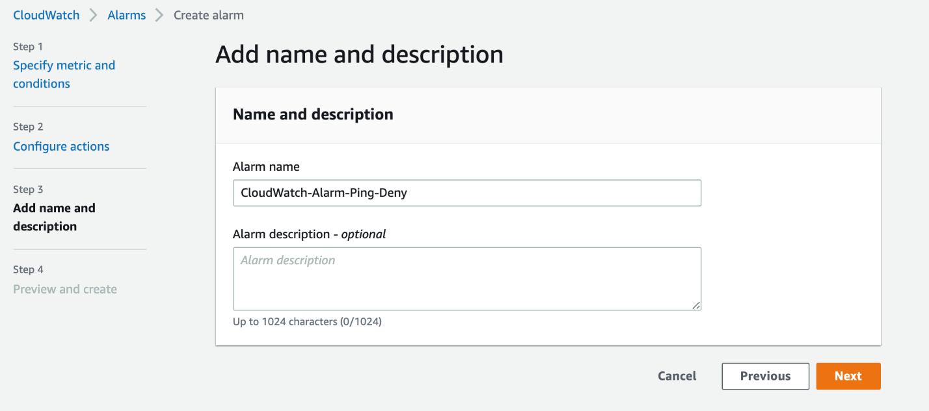

* 1. Preview the details and click on the **Create alarm** button.

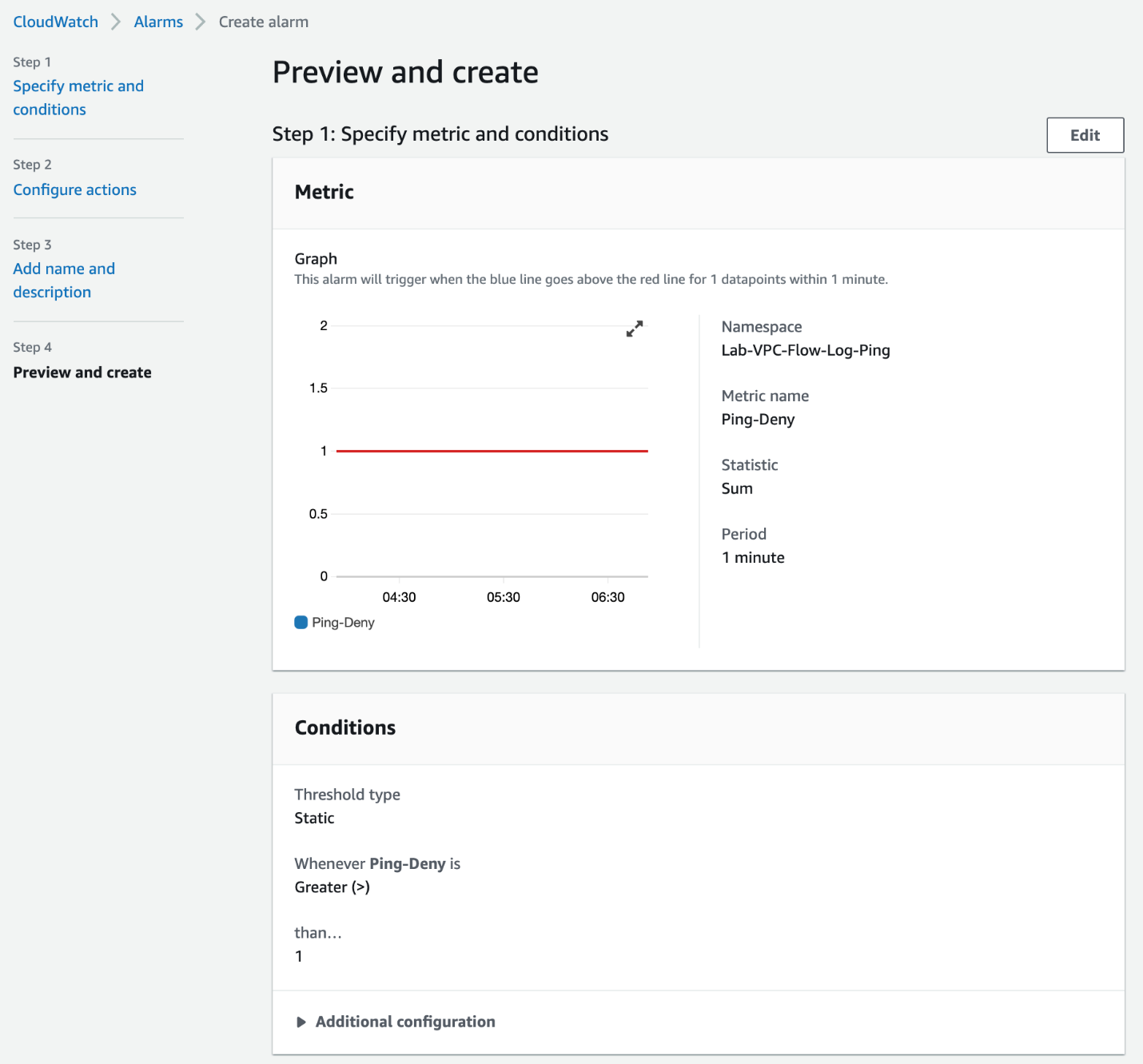

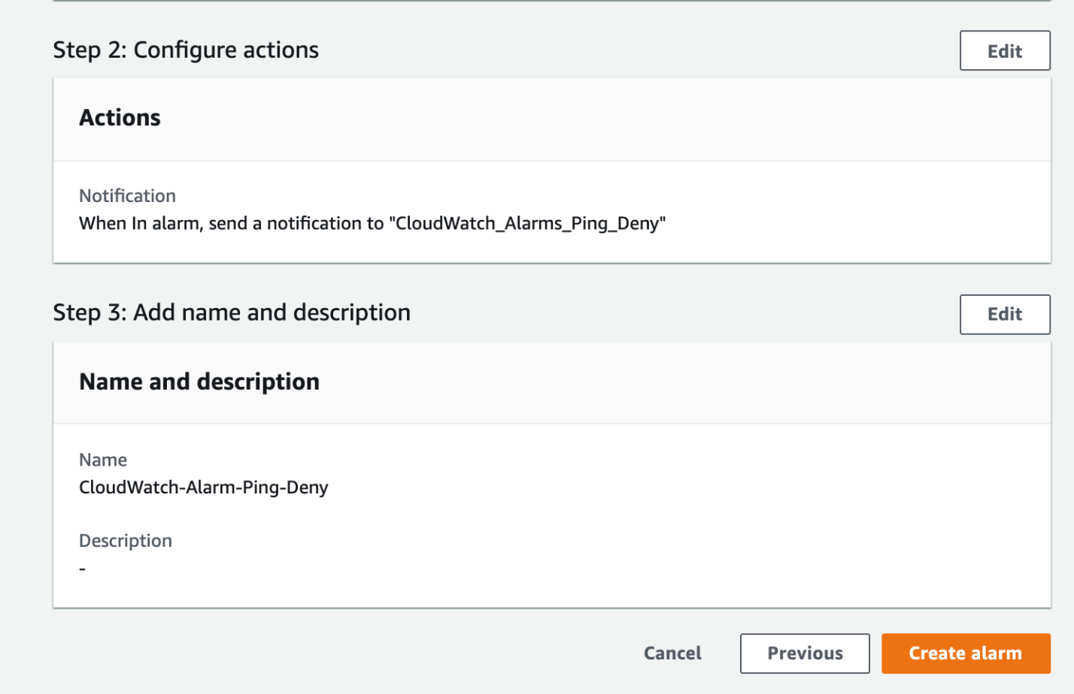

* 1. You should see that the alarm has been created successfully.

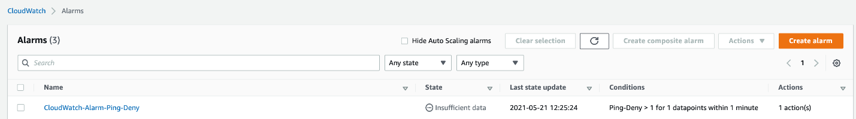

* 1. Before we proceed to trigger the alarm, you should access your email inbox and confirm the subscription for the SNS topic subscription.

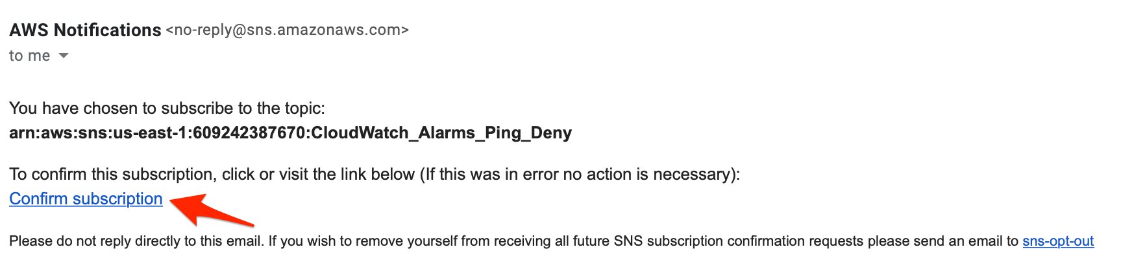

* 1. You should see that the subscription has been confirmed successfully.

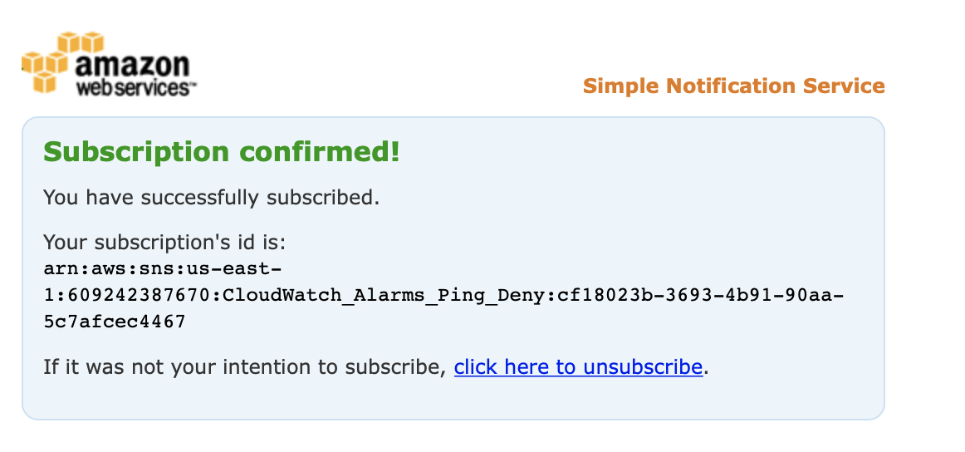

1. Navigate to the EC2 service in the AWS Management Console.
   1. Click on **Instances** in the left sidebar and then select the EC2 instance you have already created. Click on the **Connect** button.



* 1. Select the **EC2 Instance Connect** tab and click on **Connect**.



* 1. Lets try to send some traffic over the ICMP protocol by sending a ping to google.com. Type the command `ping google.com` on the terminal window and press Enter. Since the NACL has a deny rule for the outbound ICMP traffic, you would not receive any response. Enter Ctrl+C to exit.

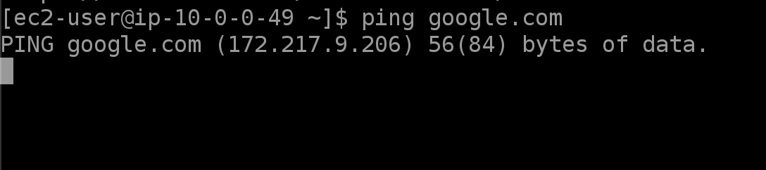

* 1. This would result in a REJECT event for the CloudWatch metric-filter that would trigger the CloudWatch Alarm. Navigate to the CloudWatch service in the AWS Management Console and click on the **Alarms** link on the left sidebar. Select the alarm CloudWatch-Alarm-Ping-Deny to view the details. You may need to wait for a few minutes for the alarm state to change to **In alarm**.

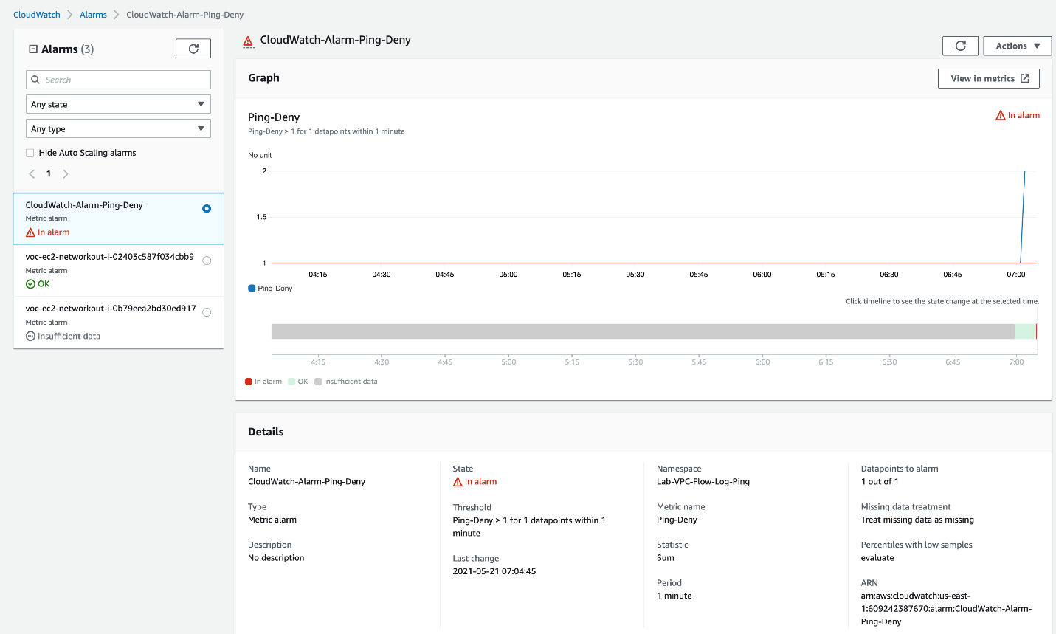

* 1. You should also receive an email with the details of the alarm.

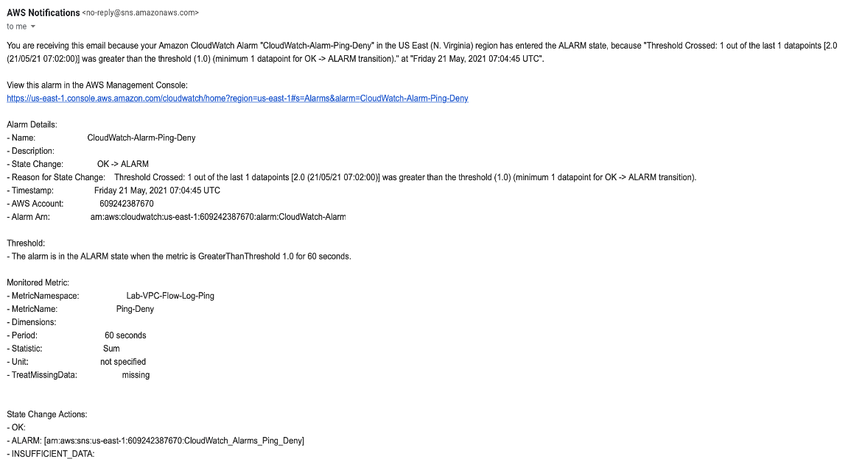

<https://docs.aws.amazon.com/AmazonCloudWatch/latest/logs/WhatIsCloudWatchLogs.html>

<https://docs.aws.amazon.com/AmazonCloudWatch/latest/logs/MonitoringLogData.html>

<https://docs.aws.amazon.com/AmazonCloudWatch/latest/monitoring/AlarmThatSendsEmail.html>

Use Athena to analyze the access trend for the VPC Flow Logs stored in S3

To implement this step, you need to set up an Athena table that reads the VPC Flow Logs data from S3 to analyze the access trends for the VPC Flow Logs stored in S3. You will write an Athena query to analyze the logs with the rejected traffic records.

1. Make sure that you are in the N.Virginia AWS Region on the AWS Management Console. Enter **S3** in the search bar and select **S3**service.

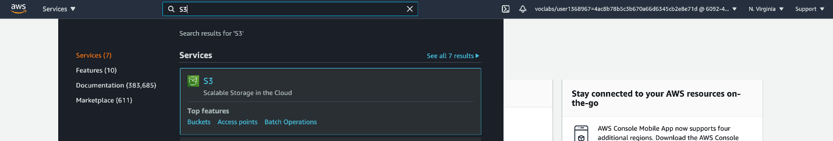

You should see the S3 bucket that you have already created.

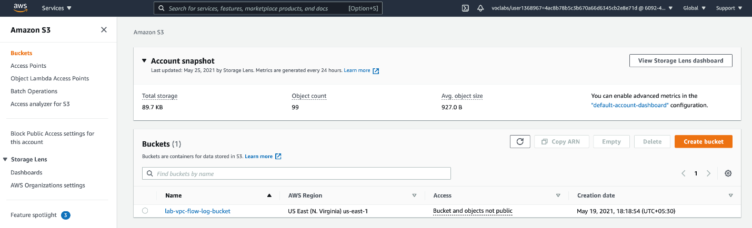

Follow the folder path to inspect the VPC flow logs already created in this S3 bucket. You should see multiple log files at the end of the folder path like so:

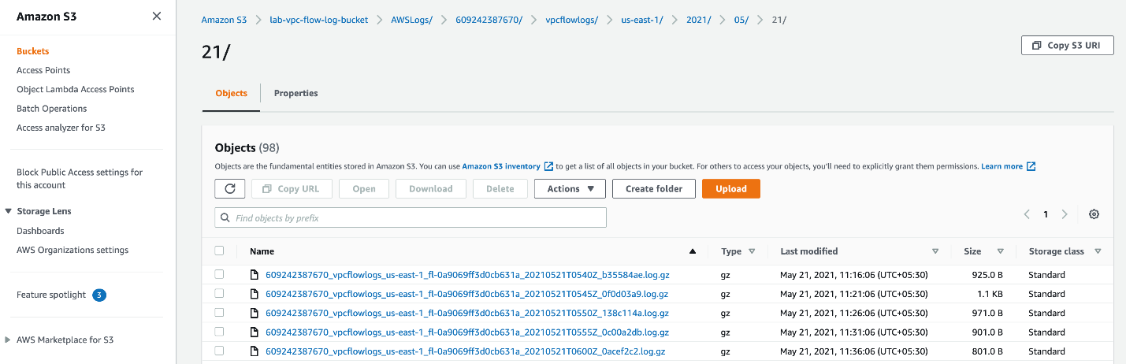

1. Lets create a folder in your S3 bucket that will be used to save the Athena query results
   1. Navigate to your S3 bucket and click on the **Create folder** button

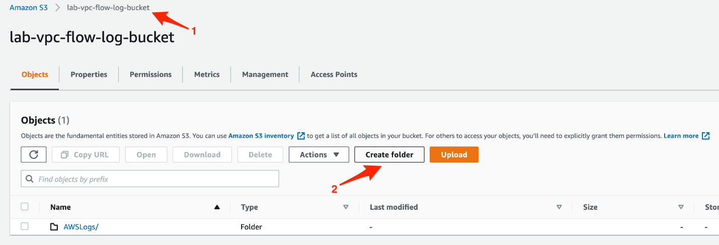

* 1. Enter the **folder name** as **AthenaQueryResults** and click on the **Create folder** button

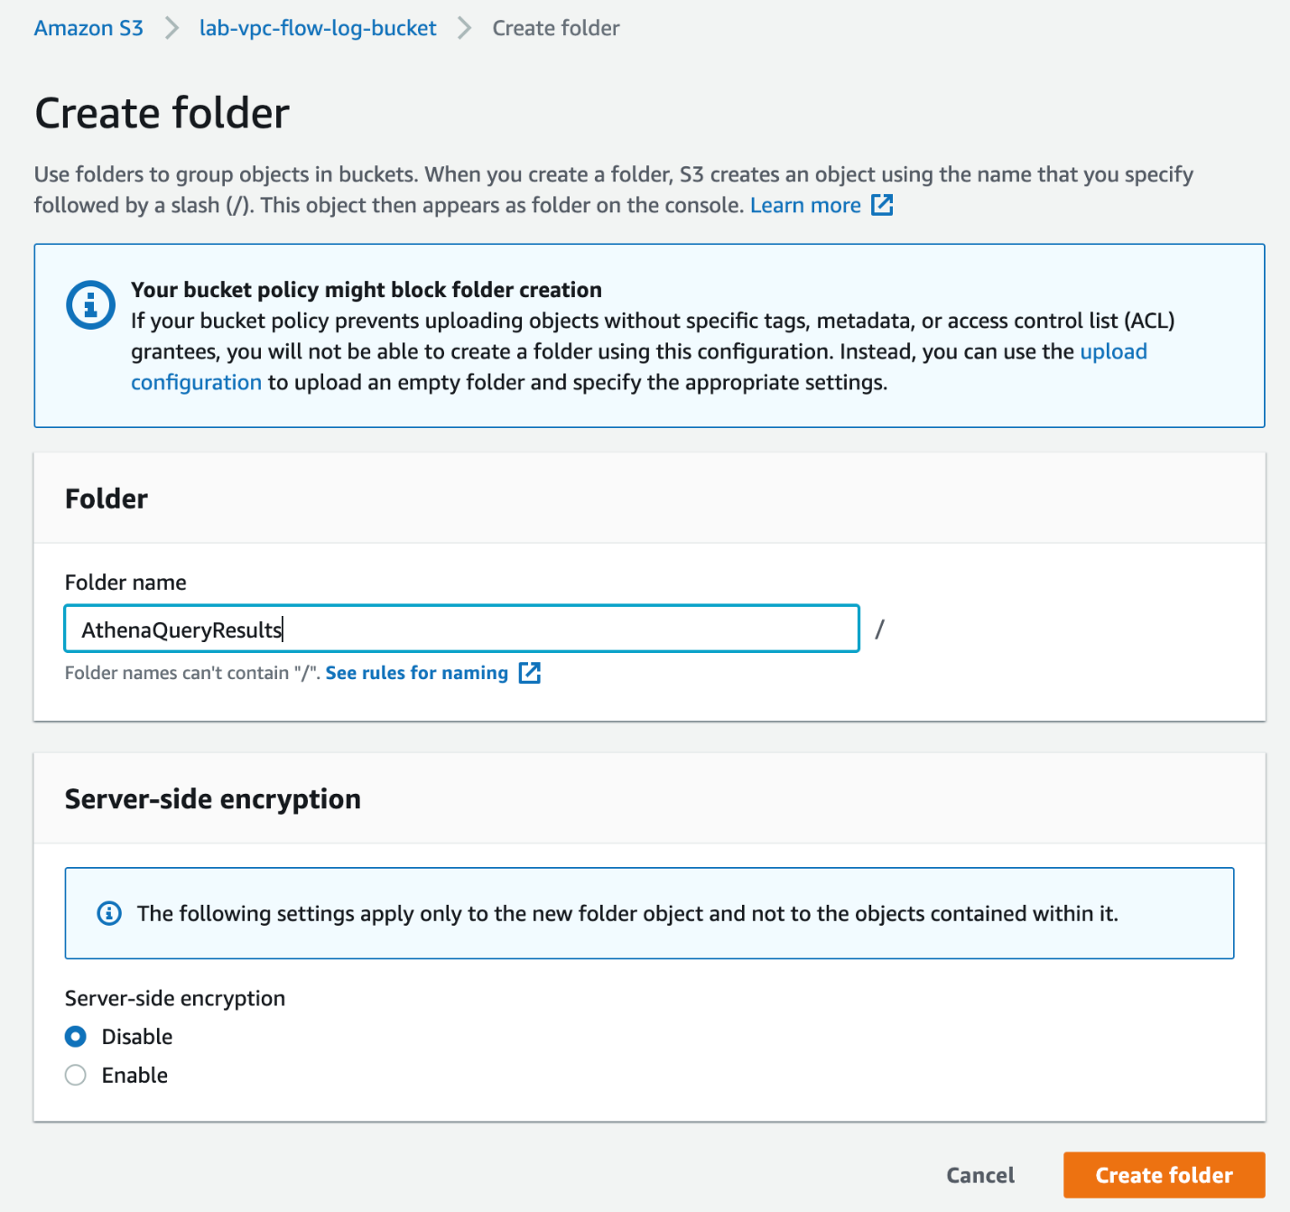

1. You will now create the Athena database and table for analyzing the VPC flow logs.
   1. Navigate to the Athena service in the AWS Management Console.

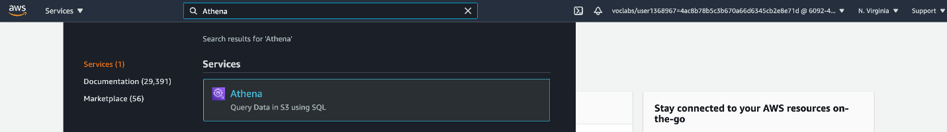

* 1. You will see a prompt to configure a query result location. Click on the link to complete this configuration.

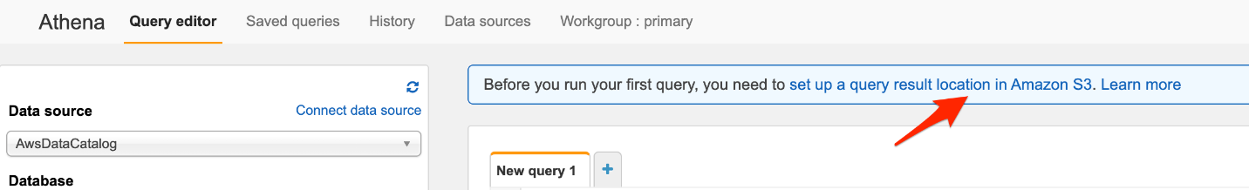

* 1. Enter the S3 location as the query result location. Click on the **Select** button and finally click on the **Save** button.

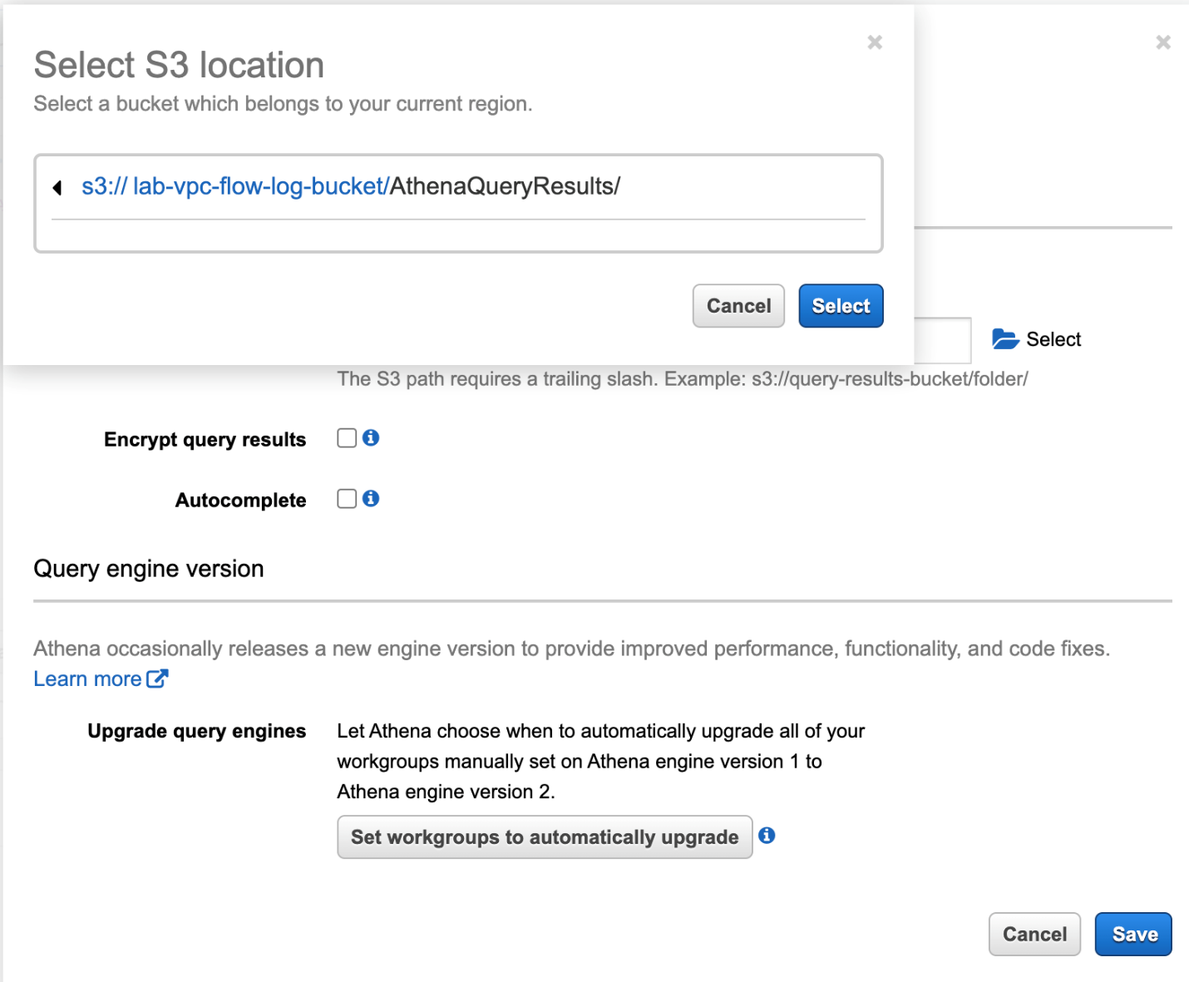

* 1. Enter the query - **CREATE DATABASE lab** - to create your Athena database. Click on the **Run query** button.

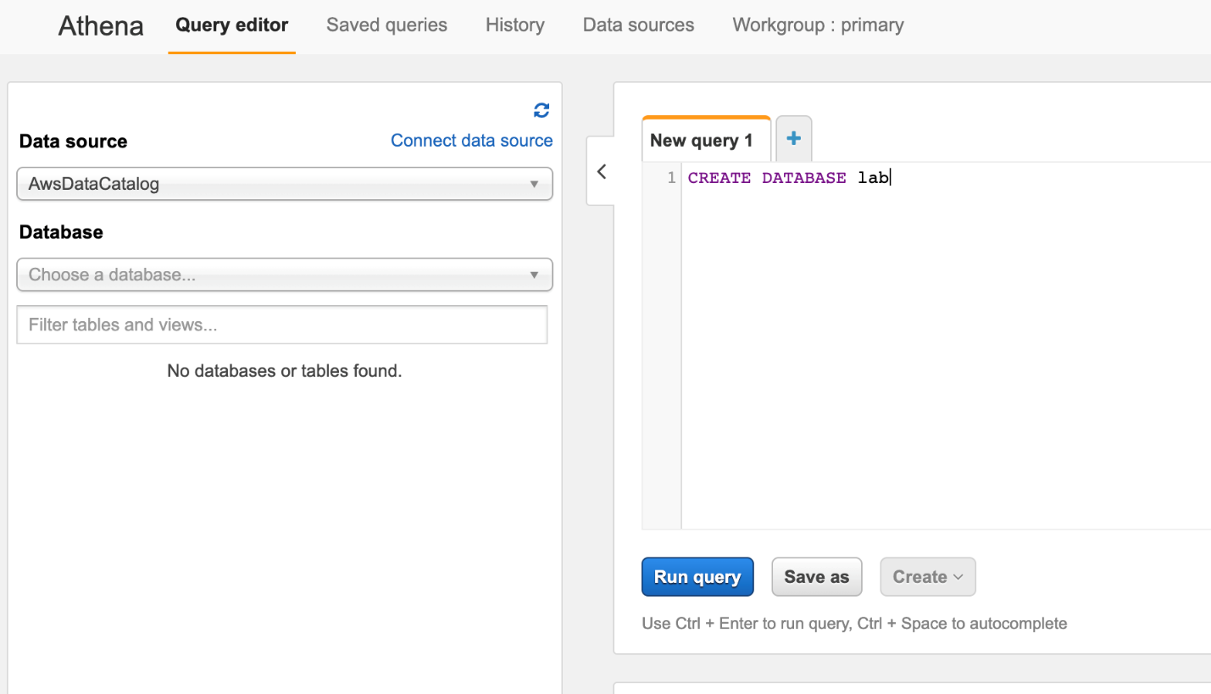

* 1. Now you will create the Athena table that will be used to analyze the VPC flow logs. Run the following query. Make sure that you modify the table location to fit your S3 bucket and the account ID.
     1. CREATE EXTERNAL TABLE IF NOT EXISTS lab.vpc_flow_log (
     2. version int,
     3. account string,
     4. eni string,
     5. source string,
     6. destination string,
     7. srcport int,
     8. destport int,
     9. protocol int,
     10. packets int,
     11. bytes bigint,
     12. starttime int,
     13. endtime int,
     14. action string,
     15. flowlogstatus string
     16. )
     17. PARTITIONED BY (
     18. `year` string,
     19. `month` string,
     20. `day` string)
     21. ROW FORMAT DELIMITED
     22. FIELDS TERMINATED BY ' '
     23. LOCATION 's3://lab-vpc-flow-log-bucket/AWSLogs/609242387670/vpcflowlogs/us-east-1/'
     24. TBLPROPERTIES ("skip.header.line.count"="1");

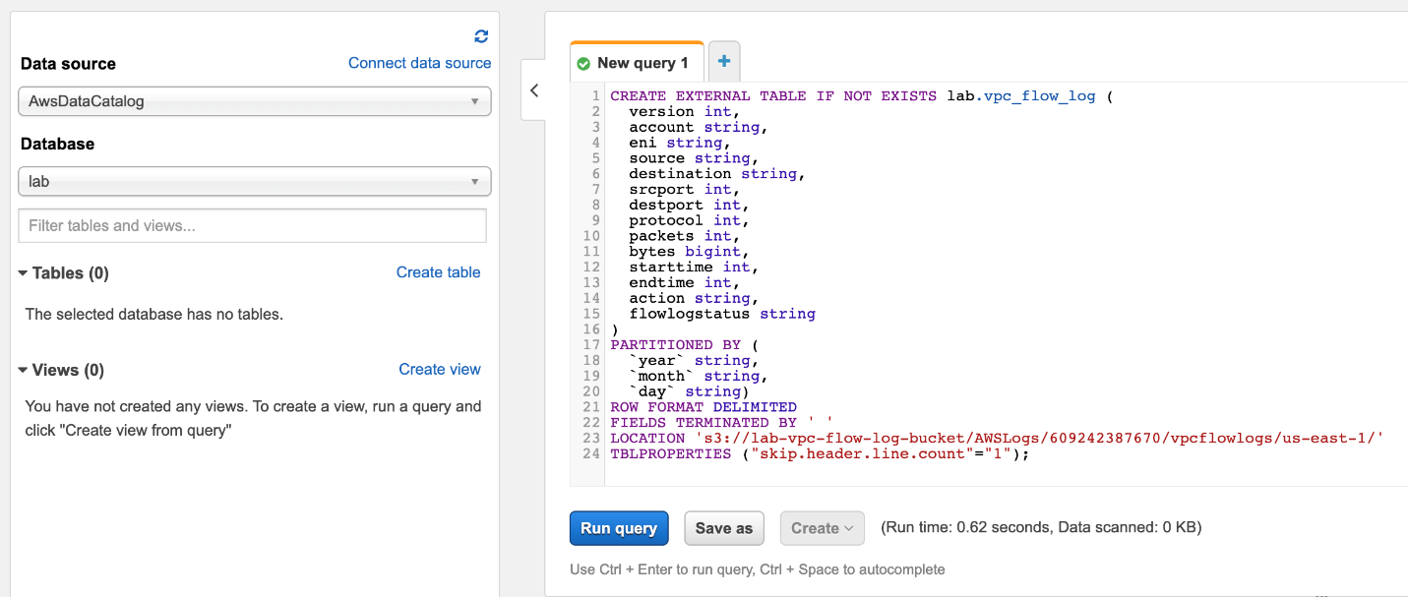

* 1. Add partitions to the table by running the following query. Make sure that you modify the partition date values and the location path to fit your S3 location.
     1. ALTER TABLE lab.vpc_flow_log
     2. ADD PARTITION (year='2021', month='05', day='21')
     3. location 's3://lab-vpc-flow-log-bucket/AWSLogs/609242387670/vpcflowlogs/us-east-1/2021/05/21';

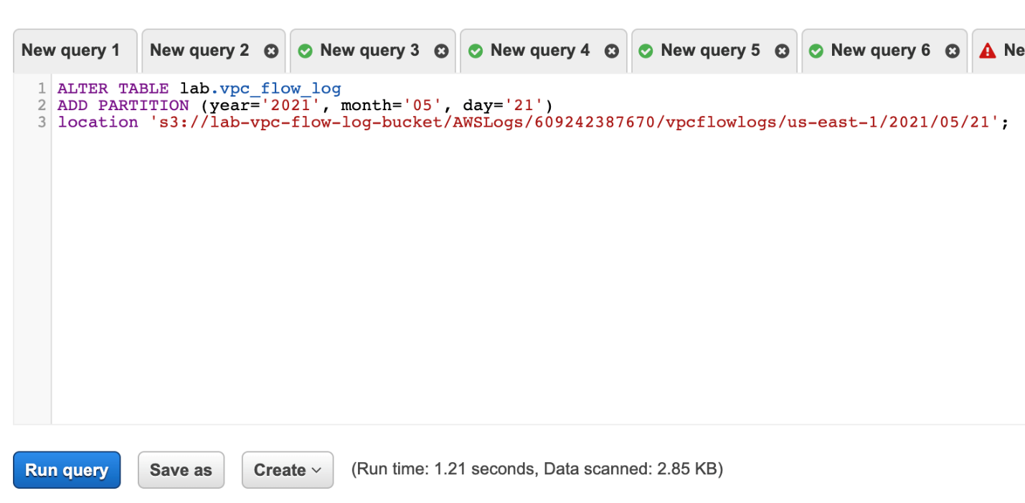

* 1. Next load the partitions to make sure that the data is available in the table. Run the following query:
     1. MSCK REPAIR TABLE lab.vpc_flow_log;

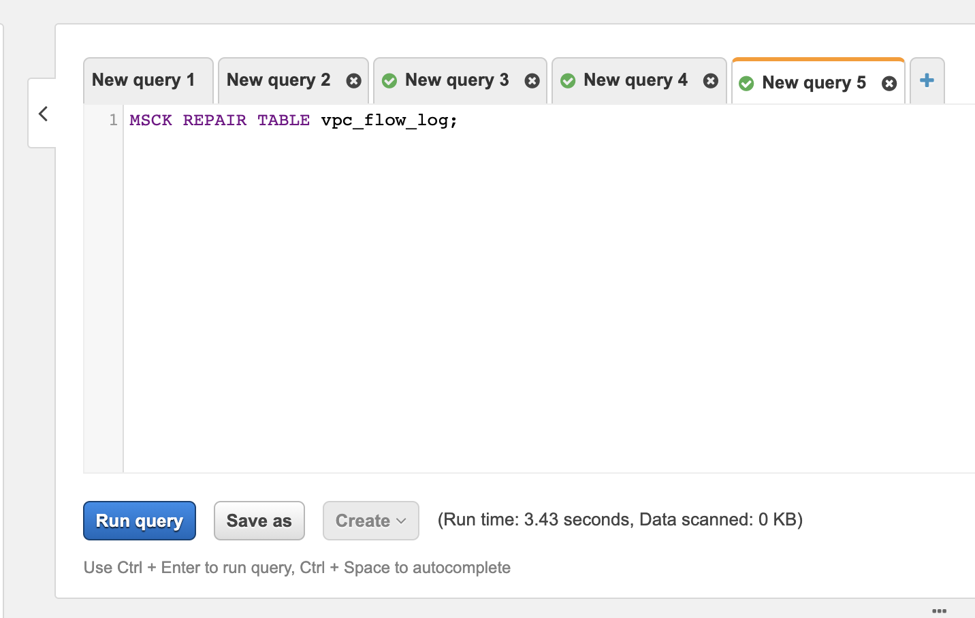

1. Now you are ready to analyze the VPC Flow Logs data using Athena.
   1. Lets run a query to see the outbound traffic (for this case, the source IP as 10.0.0.49. You will need to use the private IP for your EC2 instance that you already created) on ICMP protocol (protocol = 1). Run the following query:
      1. SELECT CONCAT(year, '-', month, '-', day) date, eni, source, destination, starttime, endtime, action, protocol
      2. FROM lab.vpc_flow_log
      3. WHERE source = '10.0.0.49' AND protocol = 1
      4. order by starttime

You can see that initially the traffic was ACCEPTed since the NACL did not have an outbound rule to deny the ICMP traffic. Once the rule was created, all subsequent ICMP traffic was REJECTed from the given source.

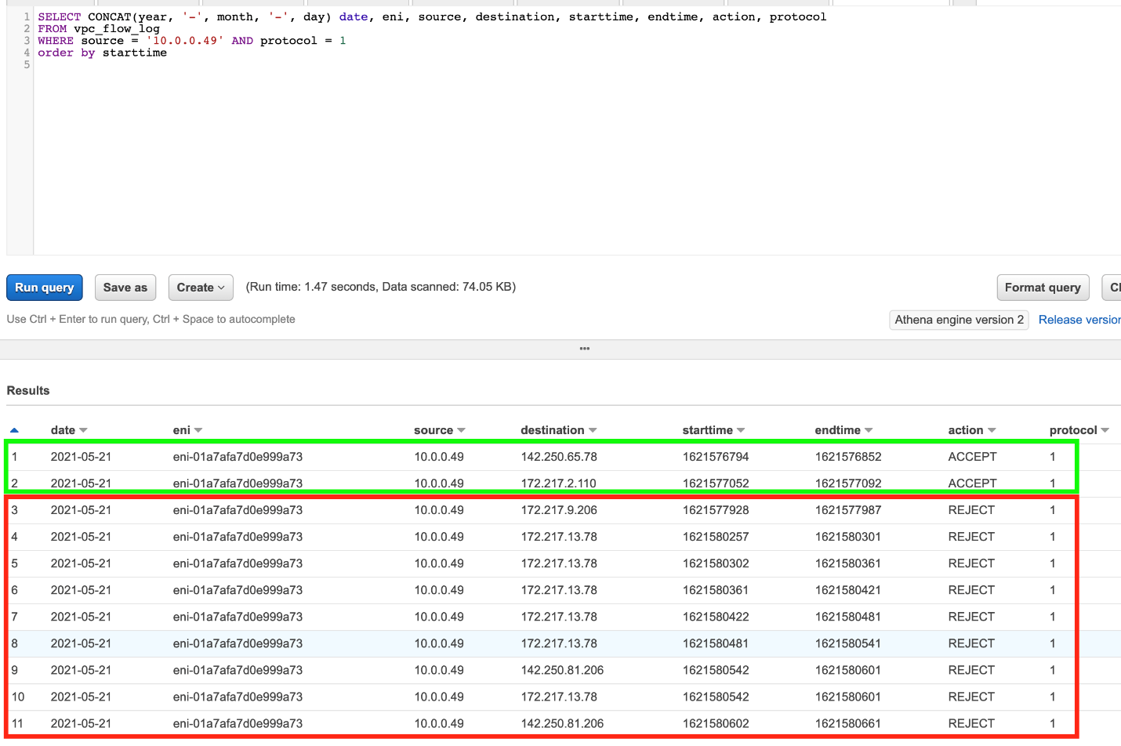

* 1. Lets run a query to analyze all types of REJECTed traffic.
     1. SELECT CONCAT(year, '-', month, '-', day) date, eni, source, destination, starttime, endtime, action, protocol
     2. FROM lab.vpc_flow_log
     3. WHERE action = 'REJECT'
     4. order by starttime

You can see that the TCP traffic (protocol=6) and UDP traffic (protocol=17) has been REJECTed for the given ENI.

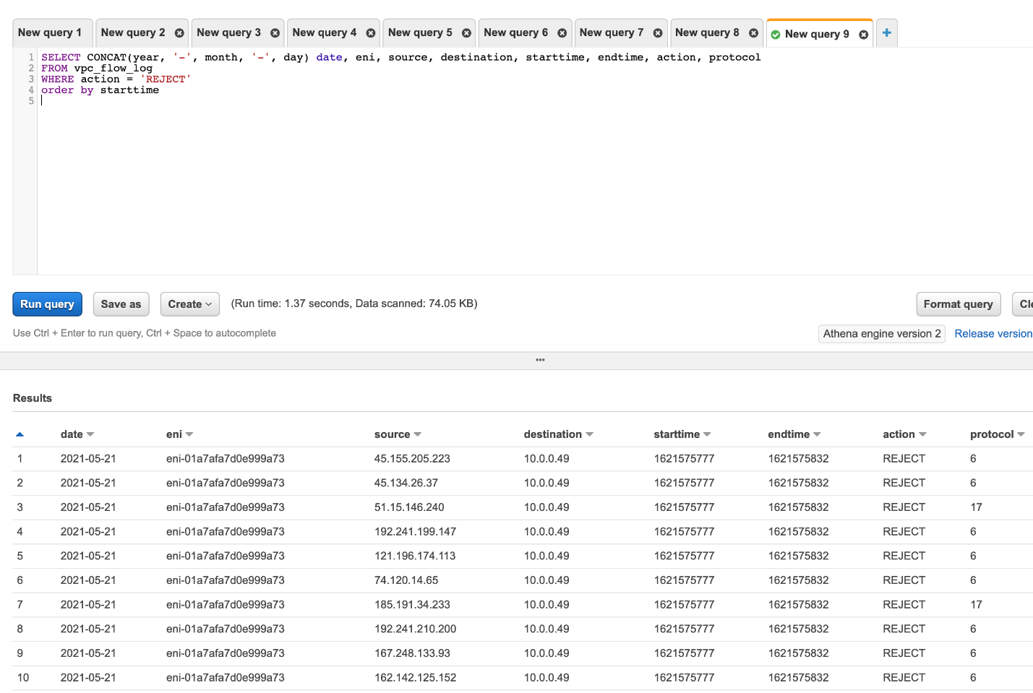

In this way, we have demonstrated that the VPC flow logs data is useful for monitoring and analyzing the traffic patterns across your VPC, subnets and any ENIs within your VPC.

<https://docs.aws.amazon.com/AmazonS3/latest/userguide/Welcome.html>

<https://docs.aws.amazon.com/athena/latest/ug/what-is.html>

<https://docs.aws.amazon.com/athena/latest/ug/partitions.html>

<https://docs.aws.amazon.com/athena/latest/ug/querying-athena-tables.html>

Clean Up

As part of this lab, you created a custom VPC, an EC2 instance and a VPC Flow Log to monitor the traffic for the instance.

1. Navigate to the EC2 service on the AWS management console. Select the **Instances**link on the left sidebar. Select the EC2 instance that you created. Click the **Instance state**button, select **Terminate instance**and then click on **Terminate**.
2. Navigate to the CloudWatch service
   1. Delete the log group - **Lab-VPC-Flow-Log-Group**
   2. Delete the CloudWatch alarm:**CloudWatch-Alarm-Ping-Deny**
3. Navigate to the Athena service on the AWS management console and delete the table **vpc_flow_log**by running the following query on the Athena query console:
   1. DROP TABLE lab.vpc_flow_log;

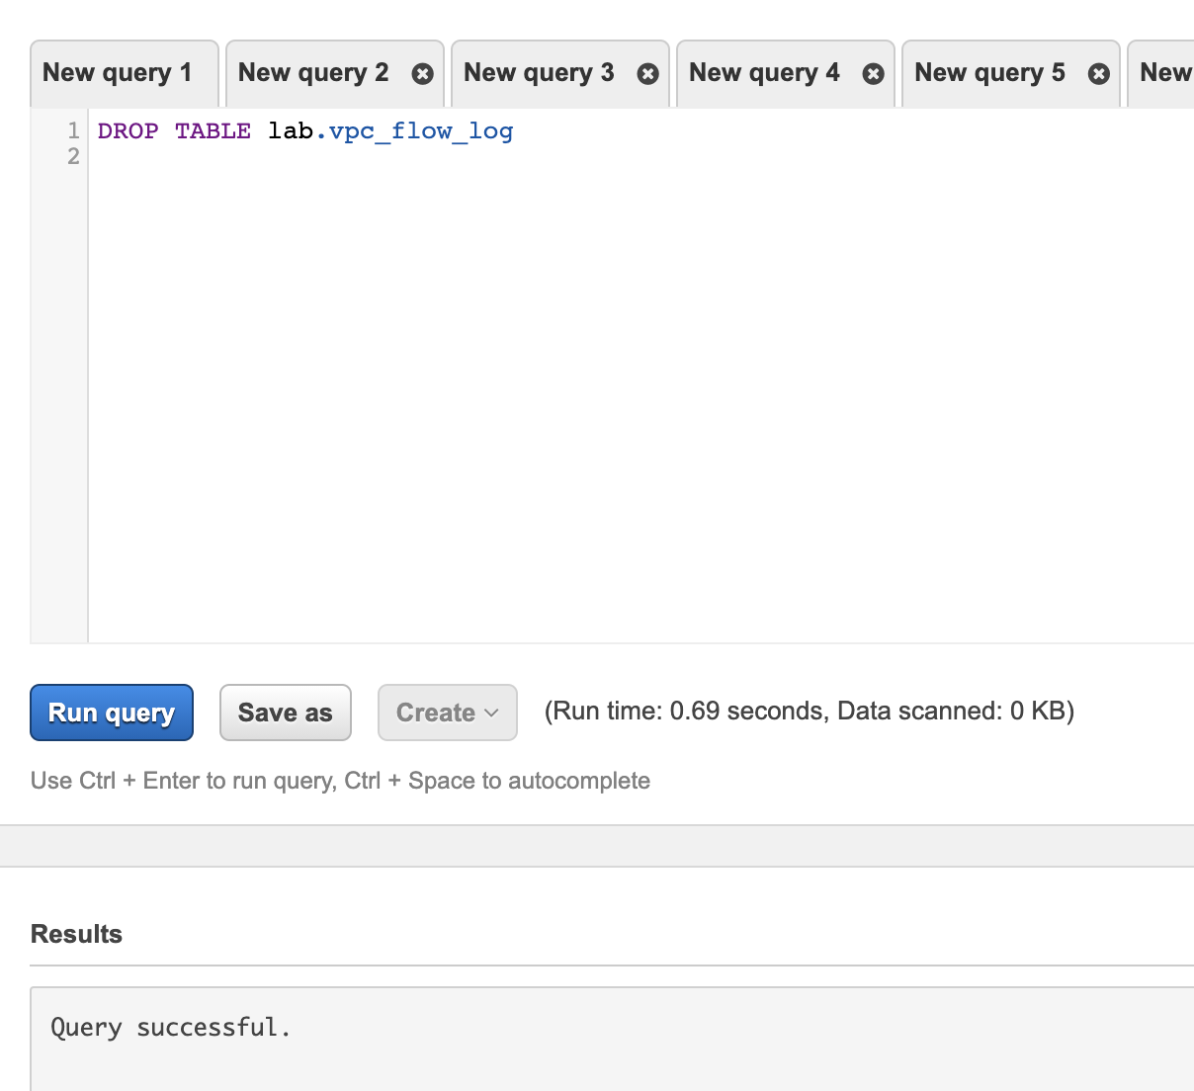

1. Navigate to the S3 service, click on your S3 bucket and then delete all content for your S3 bucket (for this case, **lab-vpc-flow-log-bucket**)

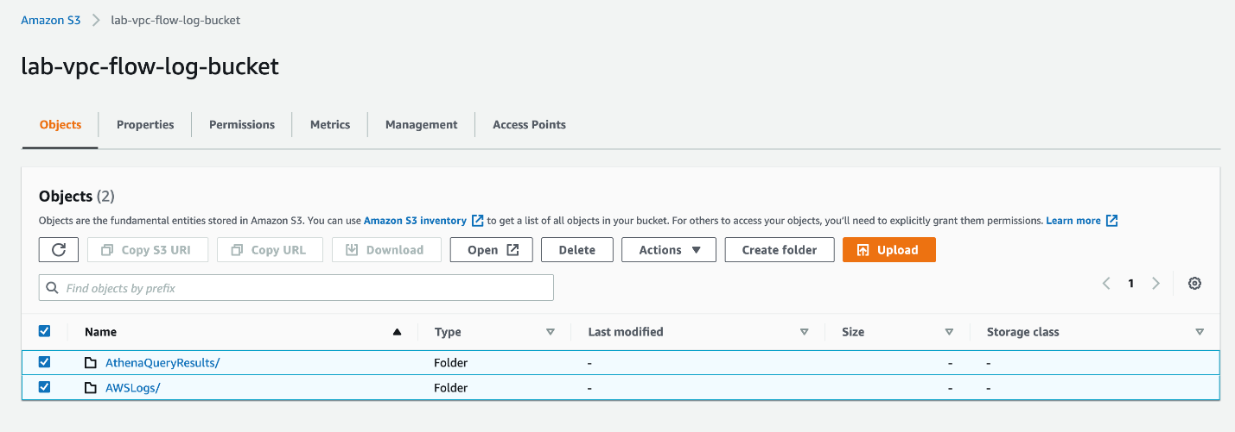

Type **permanently** **delete** in the confirmation textbox and then click on the **Delete objects** button.

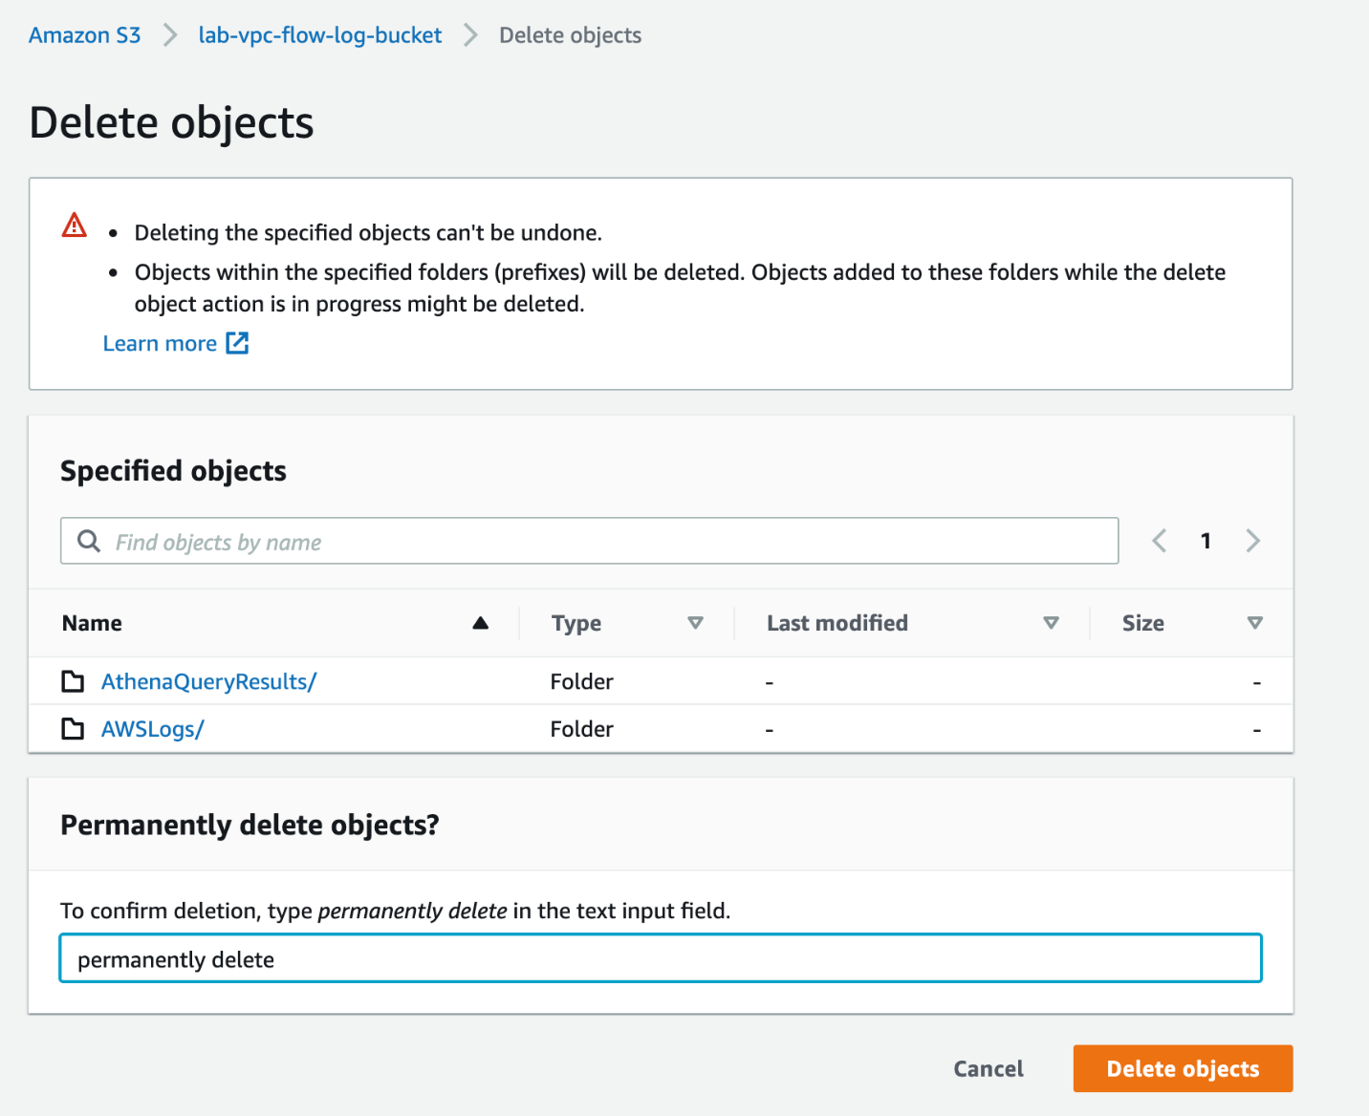

Now, navigate back to the S3 service and delete your S3 bucket by selecting your S3 bucket name and then clicking on the **delete** button.

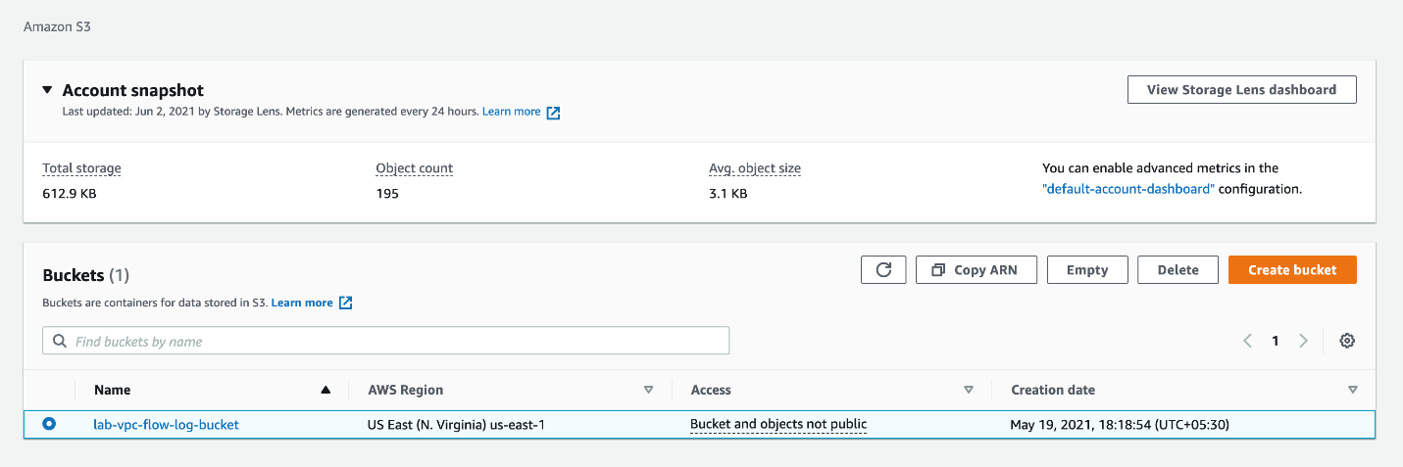

Type in the name of your S3 bucket and click on the **Delete bucket** button.

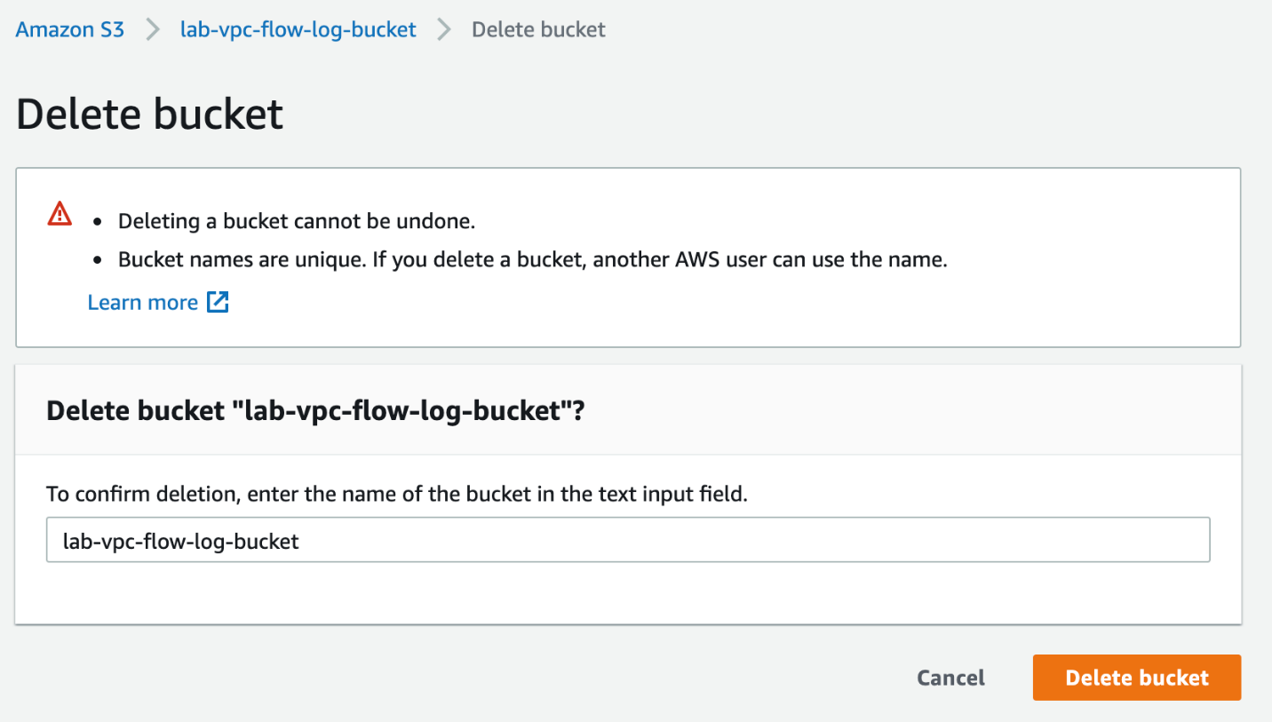

1. Navigate to the VPC service on the AWS management console. Lets delete the following resources with the following names:

VPC**: Lab-VPC-Flow-Logs**

Click on the Your VPCs link on the left sidebar, then select your VPC **Lab-VPC-Flow-Logs**, click on Actions menu and select Delete VPC.

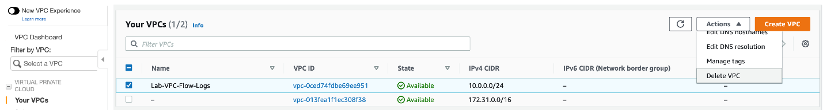

Type **delete** in the confirmation textbox and then click on the **Delete** button.

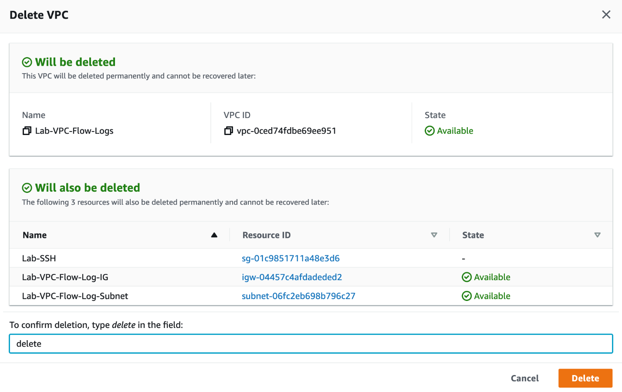

This step will also take care of the VPC-specific resources such as the route table, subnet, internet gateway and VPC Flow log created during the lab.